Online Appendix for the following JACC article

TITLE: Cost Effectiveness and Clinical Effectiveness of Catheter-Based Renal Denervation for Resistant Hypertension
AUTHORS: Benjamin P. Geisler, MD, MPH, Brent M. Egan, MD, Joshua T. Cohen, PhD, Abigail M. Garner, MS, Ronald L. Akehurst, MFPHM, Murray D. Esler, MBBS, PhD, Jan B. Pietzsch, PhD

APPENDIX

A1: Systematic searches of the PubMed literature
To identify appropriate input parameters for the transition probabilities (i.e., incidence of clinical events and mortalities), cost, and health state utility values we performed systematic literature searches in PubMed/Medline and Google Scholar. In PubMed/Medline we used Medical Subject Headings (MeSH) as search terms wherever possible.
Example: mortality after myocardial infarction
To identify suitable parameters for the mortality after a myocardial infarction, we used combinations of the following search terms:
- "Myocardial Infarction"[Mesh]
- "mortality"[MeSh]
- 30-day
Combinations: #1 and #2; #1 and #2 and #3
Our priorities were to identify studies, whether observational or interventional, that reported short-term (e.g., in-hospital or 30-day mortalities) and long-term mortality rates which we would then convert to probabilities (after adjusting the rates to our cycle length of one month) with the following characteristics:
- Adequate sample size and follow-up time (for long-term mortalities)
- Recent publication date and time of patient recruitment
- U.S. setting for comparability to other model data
The rationale for more recent data was that certain prognoses might have improved. In the case of myocardial infarction, for example, short-term mortality rates might have about halved in a few decades with more consistent use of aspirin early on and widely available reperfusion via PTCA or thrombolytics. We would then assume much too high a mortality rate if we used older data.
List of MeSH terms used
- "Hypertension"[Mesh]
- Resistant[All Fields] AND "Hypertension"[Mesh]
- Resistant[All Fields] AND "Hypertension"[Majr]
- Resistant[TI] AND "Hypertension"[Majr]
- (Resistant[TI] AND hypertension[TI]) AND "Hypertension"[Majr]
- (Resistant[TIAB] AND hypertension[TIAB]) AND "Hypertension"[Majr]
- (Resistant[TIAB] AND hypertension[TIAB]) AND "Hypertension"[Mesh]
- "Mortality"[Mesh]
- "mortality" [Subheading]
- "Hospital Mortality"[Mesh]
- "Mortality, Premature"[Mesh]
- "Costs and Cost Analysis"[Mesh]
- "Health Care Costs"[Mesh]
- "Direct Service Costs"[Mesh]
- "Hospital Costs"[Mesh]
- “Cost of Illness” [Mesh]
- "Cost-Benefit Analysis"[Mesh]
- "Markov Chains"[Mesh]
- "Quality of Life"[Mesh]
- "Diabetes Mellitus"[Mesh]
- "Myocardial Infarction"[Mesh]
- "Stroke"[Mesh]
- "Angina Pectoris"[Mesh]
- "Angina Pectoris"[Mesh] AND “unstable”
- "Angina, Stable"[Mesh]
- "Kidney Failure, Chronic"[Mesh] (End Stage Renal Disease, ESRD)
- "Heart Failure"[Mesh]
- "Coronary Disease"[Mesh]
A2: Methodology used to estimate lipid values
We used data from the NHANES 2005-8 collection period. The NHANES Analytic and Reporting Guidelines were followed (National Center for Health Statistics; Centers for Disease Control and Prevention. The National Health and Nutrition Examination Surveys: analytic and reporting guidelines. http://www.cdc.gov/NCHS/data/nhanes/ nhanes_03_04/nhanes_analytic_guidelines_dec_2005.pdf). Because NHANES does not contain information specifying whether each subject has resistant hypertension, we stratified the patients based on whether their hypertension was controlled or uncontrolled and based on the number of medications they were taking. We included only those subjects whose HT was uncontrolled despite taking three or more anti-hypertensive medications. The total sample size was 274 (n=134 for LDL). We only calculated mean values for our base case and variances for the distributions used in the probabilistic sensitivity analysis. As with many biological variables the distribution might not be not strictly normal but slightly skewed toward the upper end. Thus, the median is likely below the mean. However, we would not expect major differences, and the slightly higher values might make our analyses more conservative because the incremental effect through blood pressure reduction has a lower impact on the results if other risk factors are greater. In our analyses we accounted for the fact that NHANES had a complex survey design (multi-level probability survey) by unequal weighting using SAS-callable SUDAAN version 9.0.1.

Table A3: Incidence input parameters
Variable Name | Description | Definition | Basecase value per cycle length (one month) | Sources
pCHD | probability of CHD | if(_stage<=1;0;female*((1-EXP(-EXP((LN(_stage*cl)-m_chd_f)/scale_chd_f)))-(1-EXP(-EXP((LN((_stage-1)*cl)-m_chd_f)/scale_chd_f))))+(1-female)*((1-EXP(-EXP((LN(_stage*cl)-m_chd_m)/scale_chd_m)))-(1-EXP(-EXP((LN((_stage-1)*cl)-m_chd_m)/scale_chd_m))))) |  | (1, 2)
pESRD | probability of reaching ESRD | RateToProb(rrESRD*tESRD[age];cl) | 0.000188 | (3, 4)
pHF | probability of heart failure | female*pHFf+(1-female)*pHFm | 2.14E-04 | (5)
pHFf | probability of heart failure for women | ProbToProb((1/(1+EXP(abs(xHFf))));cl/4) | 1.01E-04 | (5)
pHFm | probability of heart failure for men | ProbToProb((1/(1+EXP(abs(xHFm))));cl/4) | 2.97E-04 | (5)
pHF_AP | probability of heart failure in AP/other CHD state | if(psa=1;dHF_AP;RateToProb(1·5;cl/100)) | 1.25E-03
pHF_MI | probability of heart failure post-MI | if(psa=1;dHF_MI;ProbToProb(·108;cl/4.91667)) | 1.93E-03 | (6)
pHF_MI30 | 30-day probability of heart failure after MI | if(psa=1;dPHF_MI30; ·231) | 0.231 | (6)
pMI | probability of MI | ProbToProb(1/(1+exp(-ymi));cl/10) | 5.85E-04 | (7)
pMI_AP | probability of MI |AP | if(psa=1;dMI_AP;pMI*tMiAP[age]) | 5.85E-04 | (8)
pstroke | probability of stroke | if(_stage=0;0;(pStrokeEarlier-pStrokeNow)/pStrokeEarlier) | 0.00E+00 | (9)
pStrokeEarlier | probability of stroke in previous state | female*(if((_stage-1)<121; tStroke_f[(_stage-1)*cl]^b_stroke_f ; (tStroke_f[10]-(0.007404659*cl*(_stage-120)))^b_stroke_f))+(1-female)*(if((_stage-1)<121; tStroke_m[(_stage-1)*cl]^b_stroke_m ; (tStroke_m[10]-(0.007404659*cl*(_stage-120)))^b_stroke_m)) | 9.95E-01 | (9)
pStrokeNow | probability of stroke in current state | female*(if(_stage<121; tStroke_f[(_stage*cl)]^b_stroke_f ; (tStroke_f[10]-(0·007404659*cl*(_stage-119)))^b_stroke_f)) +(1-female)*(if(_stage<121; tStroke_m[(_stage*cl)]^b_stroke_m ; (tStroke_m[10]-(0·007404659*cl*(_stage-119)))^b_stroke_m)) | 9.95E-01 | (9)
pStroke_AP | probability of stroke in AP/other CHD state | if(psa=1;dStroke_AP;RateToProb(1·1;cl/100)) | 9.16E-04

Table A4: Mortality input parameters
Variable Name | Description | Definition | Basecase value per cycle length (one month) | Sources
pDie | Mortality | female*RateToProb(tMortOther_f[age];cl)+(1-female)*RateToProb(tMortOther_m[age];cl) | 6.78E-04 | (10)
pDieESRD | probability of death in ESRD state | if(psa=1;dPdieESRD;If(ptDieESRD<1;ProbToProb(ptDieESRD;12*cl);1)) | 9.93E-02 | (11)
pDie_AP | probability to die in AP/other CHD state | if(psa=1;dPdieAP;female*ProbToProb(tDieAPf[age];cl)+(1-female)*ProbToProb(tDieAPm[age];cl)) | 1.32E-03 | (8) and below
pDie_HF 30 | 30-day mortality after HF onset | tRRhfage[age;1]*female*·04+tRRhfage[age;2]*(1-female)*·06 | Table | (12, 13)
pDie_HFy1 | probability of death from heart failure year 1 (beyond 1st month) | tRRhfage[age;1]*female*·0124+tRRhfage[age;2]*(1-female)*·0147 | Table | (12, 13)
pDie_HFy2 | probability of death from heart failure year 2 and following | tRRhfage[age;1]*female*·0071+tRRhfage[age;2]*(1-female)*·0071 | Table | (12, 13)
pDie_MI | long-term mortality from MI | RateToProb(ProbToRate(tDieMI[sbp;yr]; 1/if(psa=1;if(age<60;1;if(age>=70;dRRdieMI70s;dRRdieMI60s));tRRdieMIage[age])*cl);1) | Table | (14-16)
pDie_MI30 | 30-day mortality after MI | if(psa=1;dPdieMi30;tDieMI30[age]) | 7.3E-02 | (14)
pDie_Stroke | long-term probability to die from stroke | ProbToProb(pDie;2.3) | 1.56E-03 | (17)
pDie_Stroke30 | 30-day mortality after stroke | if(psa=1;dPdie_stroke30;.126) | 0.126 | (18)
ptDieESRD |  | if(_tunnel=1;tDieESRDintercept[age]+tDieESRDslope[age]*_tunnel;(tDieESRDintercept[age]+tDieESRDslope[age]*_tunnel)-(tDieESRDintercept[age]+tDieESRDslope[age]*(_tunnel-1))) | 0.0993 | (11)
Table A5: Relative risks
Variable Name | Description | Definition | Value | Source
RRdieStrokeCHF | relative risk of dying from stroke if previous CHF |  | 2.189 | (19, 20)
RRdieStrokeMI | relative risk of dying from stroke if previous MI |  | 2.99 | (21)
RRdieStrokeMi_30 | relative risk of dying from stroke in the first month if previous MI |  | 2.27 | (21)
rrESRD | relative risk of ESRD | -3·109577+sbp*·0391452 | 3.5646796 | (3)
rrStrokeESRD | relative risk for stroke in ESRD patients | female*aa_fem*6·2+female*(1-aa_fem)*9·7+(1-female)*aa_m*4·4+(1-female)*(1-aa_m)*6·1 | 6.463023 | (22)

Table A6: Cost input parameters.
Health State |  | Cost (range) | Reference
Stroke | Acute | $18,627 ($8,874 to $65,776) | (23)
Stroke | 1st year beyond acute | $30,801 ($8,121 to $65,695) | (23)
Stroke | 2nd and following years | $27,899 ($13,922 to $65,965) | (24)
MI | Acute | $21,127 ($8,260 to 48,288) | (25)
MI | 1st and following years beyond acute | $3,750 ($0 $10,504) | (26)
HF | 1st year | $14,532 ($7,071 to $32,245) | (27)
HF | 2nd and following years | $5,212 ($3,958 to $10,904) | (27)
Angina | Stable – annually | $3,674 ($2,746 to $6,470) | (28, 29)
Angina | Unstable – annually | $7,104 ($4,356 to $9,852) | (30)
ESRD | DM Patients annually | $76,851 ($53,935 to $89,882) | (11)
ESRD | Other patients annually | $66,844 ($45,159 to $79,350) | (11)
HTN | Annually | $868 ($203 to $1,355) | (31) (office & provider visits, plus medication costs)
RDN | Once | $12,500 ($8,000 to $15,000) | (32) (Includes cost for Symplicity catheter and procedure)
MI: myocardial infarction; HF: heart failure; ESRD: end-stage renal failure; DM: diabetes mellitus; HTN: hypertension; RDN: renal denervation treatment.
All parameters are in 2010 U.S.$.

Table A7: Health state utility values
Health State |  | Utility (Range) | Reference
Stroke |  | 0.63 (0.26 to 0.92) | (33, 34)
MI | First six months | 0.76 (0.50 to 0.87) | (35, 36)
MI | Following | 0.88 (0.67 to 0.94) | (33, 37)
HF |  | 0.71 (0.43 to 0.84) | (38, 39)
Angina | Stable | 0.84 (0.62 to (0.90) | (40) (recalibrated based on 60-69 yr. age group); see also(41)
Angina | Unstable | 0.74 (0.53 to 0.83) | (36)
ESRD |  | 0.63 (0.46 to 0.84) | (42) (dialysis patients)
HTN |  | 0.96 (0.79 to 0.98) | (40) (recalibrated based on 60-69 yr. age group)
All utilities were age-adjusted by the following multiplier (43)
Age group | Multiplier
18-29 yrs. | 0.922
30-39 yrs. | 0.901
40-49 yrs. | 0.871
50-59 yrs. | 0.842
60-69 yrs. | 0.823
70-79 yrs. | 0.79
80+ yrs. | 0.736

Figure A8: Validation via Joint National Committee and Anderson et al. relative risks

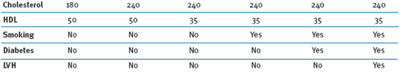
RR: 0.53 0.57 0.63 0.74 0.80 0.82
95% CI: 0.40-0.68 0.41-0.75 0.44-0.79 0.50-0.87 0.55-0.89 0.56-0.90

Absolute risks:
Scenario | Study  120 | Study  180 | Model  120 | Model  180
1 | 5.8% | 12.4% | 6.1% | 11.4%
2 | 7.9% | 16.5% | 8.0% | 14.0%
3 | 11.6% | 23.4% | 10.6% | 16.8%
4 | 22.0% | 40.6% | 16.8% | 22.6%
5 | 34.9% | 59.7% | 21.8% | 27.0%
6 | n.a. | n.a. | 20.5% | 24.9%

Sources: (44, 45)
A9: Results and interpretation of additional validation attempts
The main validations performed on the model are the reported JNC7/Anderson relative risk comparisons and the comparison to the projections of the UK NICE hypertension model.
Additional validation attempts:
During model development, some attempts were made to perform comparisons of model predictions vs. event rates reported for the placebo arms in several larger hypertension RCTs. However, as we realized, these validation efforts were fraught with a number of challenges that make these validations questionable. A main issue are partly missing cohort characteristics (such as full lipid profiles), which raise the question whether the validation procedure would indeed be a “valid” approach to check the model.
With this caveat, we decided to include the results of these additional attempts below (comparisons to ADVANCE, ASCOT-BPLA, and CAMELOT). All RCT-reported results lie comfortably within the 95% credible intervals (CIs) of the trial-informed simulation model results, al. The results tend to show a tendency of over- rather than underprediction, primarily in the MI-related events “CV mortality” and “total coronary endpoint.”
The graphs below include the medians and 95% credible intervals of the trial-informed model results from our probabilistic sensitivity analyses with 5,000 2nd-order Monte Carlo simulation runs each. The purple quadrangles show the study-reported means while the green triangles represent the medians of the model-obtained projections; the lines represent the 95% credible intervals.
As mentioned above, we were only able to obtain these model projections through partly guessed baseline characteristics, a fact that limits the validity of the validation efforts themselves. For example, the ADVANCE study reported total cholesterol and HDL, but neither LDL nor triglycerides, and CAMELOT reported only LDL. The effect of the necessary guesses is discussed further below.

ADVANCE*:

ASCOT-BPLA*:

CAMELOT*:

* Validation attempts, subject to outlined limitations and caveats.

Discussion of issues and limitations with these validations:
To illustrate the issue raised by parameter guesses, we calculated the effect of triglycerides on model projections: when assuming a triglyceride level at the lower end of the age-appropriate normal range, for example, one gets much lower proportions of endpoints reached, compared to the projections show in the graphs above.

ADVANCE:
All-cause mort. 15.6% → 9.9% (8.5% reported in RCT)
CV mort. 8.4% → 2.4% (4.6% reported in RCT)
Stroke: 3.6% → 3.7% (3.9% reported in RCT)
Total coronary events: 17.8% → 9.5% (9.6% reported in RCT)

CAMELOT:
All-cause mort: 2.1% →1.9% (0.9% reported in RCT)
CV mort: 0.4% → 0.1% (0.3% reported in RCT)

It is unclear which triglyceride value is an appropriate assumption for each validation, and thus which model projection result should be used for comparison about the study-reported values.
For a number of other input parameters that are not reported either, similar issues exist.
Interpretation of results:
All RCT-reported results lie comfortably within the 95% CIs of the simulation-obtained model projections. The results shown in the graphs suggest a tendency of model-overprediction rather than under-prediction, especially in the MI-related event rates (“CV mortality”, “total coronary endpoint”).
To test the effect of such tendency to overpredict, we performed two scenario analyses in which we multiplied our model’s transition probability into the MI state, p_MI, by 0.5 and 0.333, i.e. reducing incidence rate to one half or one third of the basecase assumption used in the model, and evaluated the effect of this change on the primary health-economic outcome (ICER) and on the primary clinical outcome measure (10-yr. RR of clinical event). The effects were as follows:
- Multiplying p_MI by 0.5 led to an ICER of $ 1,985/QALY and a 10-yr. RR of 0.67.
- Multiplying p_MI by 1/3 led to an ICER of $ 1,487/QALY and a 10-yr. RR of 0.67.

As can be observed, these reductions in event incidence would have led to only minimal changes that would have translated into slightly more favorable results for RDN, considering the base case ICER of $ 3,071/QALY and the 10-yr. RR of 0.68.
Concluding remarks:
Throughout model development, and as stated in the manuscript, we aimed to work with widely published and accepted risk equations derived from the Framingham Heart Study and the PROCAM study, and to not “calibrate” them to our model, as this might have made our event rate assumptions questionable. In light of the results of our validation efforts against the Anderson/JNC 7 scenarios and the UK NICE hypertension model, and considering the fact that the trial-reported results of the additional validations lie within the 95% CIs of the model-based projections (keeping in mind the aforementioned limitations of these RCT comparisons), we feel confident about the predictive ability of the model and the robustness of its projections.
Further, the fact that scenarios in which we reduce the MI incidence in the model lead to the essentially the same or slightly more favorable outcomes in terms of ICER and RRs, is reassuring to us.

A10: Results of the cost-effectiveness analysis with alternative discount rates
5% discount p.a. rate:
Strategy | Cost  ($) | Incremental Cost  ($) | Effectiveness  (QALYs) | Incremental Effectiveness  (QALYs) | ICER  ($/QALY)
SoC | $55,840 |  | 7.89
RDN | $59,727 | $3,887 | 8.37 | 0.48 | 8,050 $/QALY
undiscounted:
Strategy | Cost  ($) | Incremental Cost  ($) | Effectiveness  (QALYs) | Incremental Effectiveness  (QALYs) | ICER  ($/QALY)
SoC | $110,349 |  | 17.07 |  | (Dominated)
RDN | $108,580 | -$1,769 | 18.37 | 1.30

Figure Set A11: Deterministic sensitivity analyses
The following figure set presents a summary of the deterministic sensitivity analysis in a typical and useful graphic summary, the tornado diagram. This type of graph is useful for comparing the relative importance of variables that have a degree of uncertainty to those that are more stable (46).
ICER Tornado diagram. The horizontal bars represent the spread of the incremental cost-effectiveness ratio in U.S. $/quality-adjusted life year (QALY) when the given parameter was varied across a range (see legend). A bar reaching the gray-shaded area represents a cost-saving outcome. Only the eleven most influential parameters are displayed.

ICER ($/QALY)
-5K $/QALY
15K $/QALY
35K $/QALY
SBP reduction renal denervation: 15 to 40 mm Hg
discount rate: 0 to 6% per year
costs for renal denervation therapy: $8,000 to $15,000

systolic blood pressure: 160 to 200 mm Hg
costs for stroke: $8,874 to $65,776
The following analyses report lifetime (except for mortalities) incidence of clinical outcomes (SoC, SBP=178 mmHg, lifetime)
- Stroke
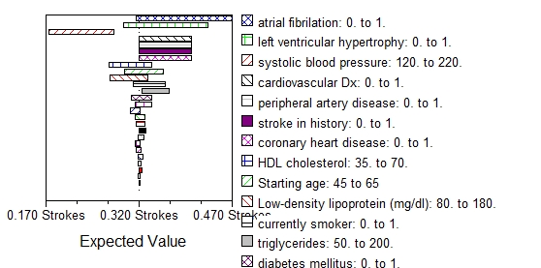

- MI

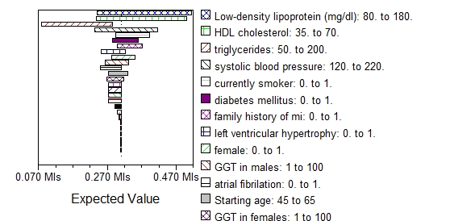

- CHD
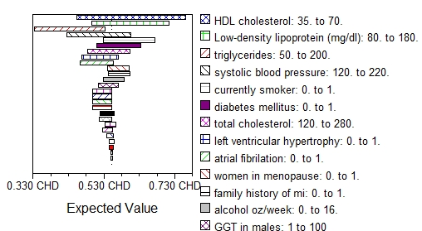

- HF
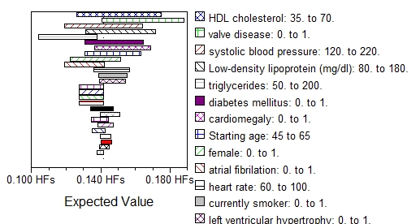

- ESRD
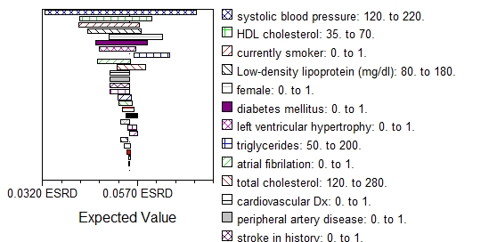

- CV mortality (ten-year time horizon)

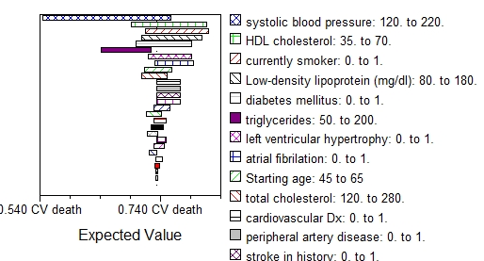

- All-cause mortality (ten-year time horizon)

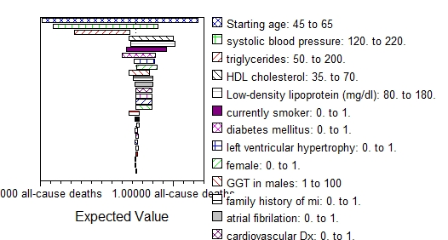

Figure Set A12: Structural sensitivity: ICER depending on pre-treatment SBP level
We conducted a post-hoc analysis of the Symplicity HTN-2 dataset. Bivariate and multivariate linear regression was used to identify statistically significant covariates (based on comprehensive dataset of clinical parameters) and to develop a predictive model for change in SBP after six months (outcome of interest). Alpha was defined as less than 0.05 for the bivariate analyses. All explanatory variables with a p<0.20 were selected for a multivariate model. We also tested for clinically feasible interaction terms. Randomization to RDN and baseline SBP were the only predictive covariates (p<0.001 and p=0.007, respectively). A higher baseline SBP was negatively correlated with SBP difference in RDN patients. SBP differences based on the multivariate model and ICERs from a one-way sensitivity analysis for baseline SBP are shown below. Calculated relative risks for clinical outcomes are shown in the subsequent graph.

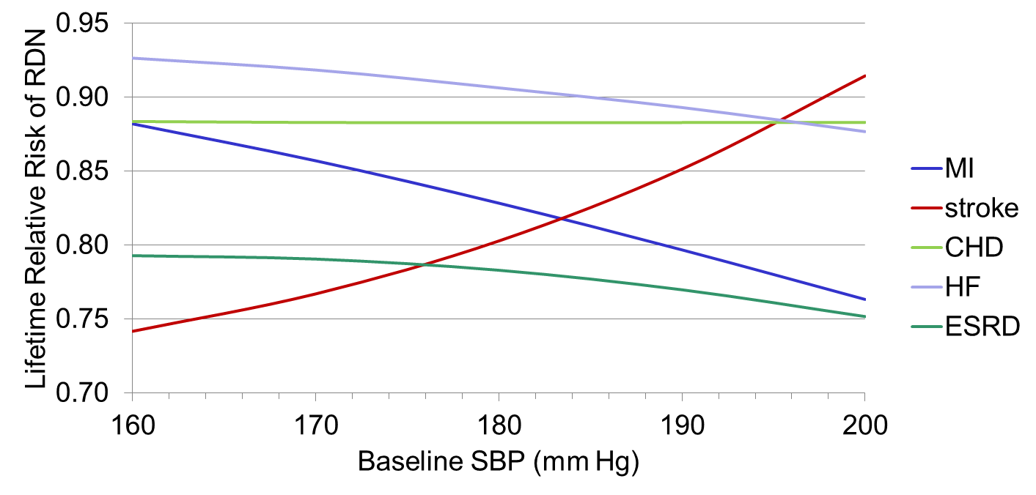

Figure A13: Structural sensitivity - threshold analysis: SBP reduction of renal denervation
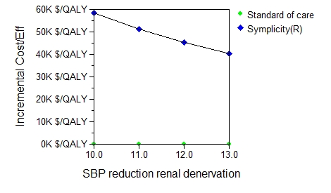

Figure A14: Structural sensitivity analysis:
Fade-out of SBP reduction of renal denervation
(hypothetical fade out in mmHg per year)

Figure A15: Structural Sensitivity Analysis: Fade-out of SBP reduction of renal denervation;
(hypothetical case of 3 repeat procedures every x years)
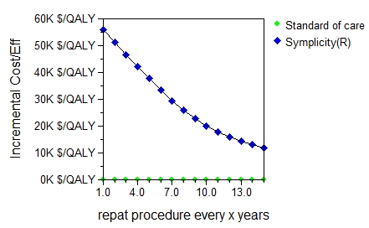

Figure A16: Two-way Sensitivity Analyses on Structural Assumptions and Effect Size

Structural sensitivity analysis on a possible decreasing treatment effect over time (left) and on possible necessity of repeat procedures (right). The two graphs are two-way sensitivity analysis over the beginning SBP reduction on the x-axis. The right-angled green-striped area marks the combination of parameters where RDN is cost-effective, i.e. the incremental cost-effectiveness ratio is less than $50,000/QALY. The diagonally blue-striped area marks the combination of parameters where RDN is not cost-effective, i.e. the incremental cost-effectiveness ratio is more than $50,000/QALY.

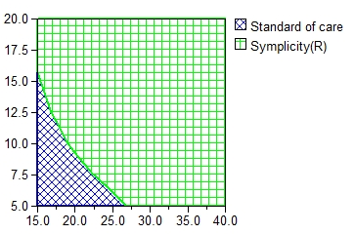
g
Decrease in systolic blood pressure reduction per year
Number of years between repeat procedures (up to two) total)
Systolic blood pressure Reduction (mm Hg)

Figure Set A17: Probabilistic Sensitivity Analysis
The figure below shows the incremental cost-effectiveness scatter plot derived from the probabilistic sensitivity analysis. The horizontal axis represents incremental effectiveness in QALYs while the vertical axis represents incremental costs. Each blue plot point corresponds to the results of a simulation using a distinct set of randomly selected parameter values. The probabilistic sensitivity analysis yielded a 95% credibility interval that ranged from cost-saving to $31,460/QALY. In all simulations, RDN improved health (i.e., incremental QALYs>0), and in 21.1% of the simulations, RDN also decreased costs (i.e., it was cost-saving).
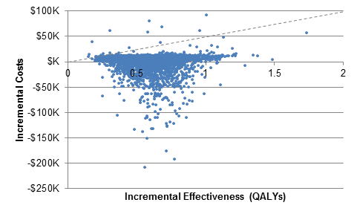

The next figure illustrates the probabilistic sensitivity analysis results in the form of a cost-effectiveness acceptability curve. The proportion of cost-effective simulations at given willingness-to-pay level (in $/quality-adjusted life year on the x-axis) can be read on the y-axis. For example, approximately 97% of the simulation results are less than $30,000/QALY, meaning that the PSA results indicate there is a 97% chance that the ICER is less than $30,000/QALY. The results also indicate that there is a 99.6% probability that the ICER is less than the $50,000/QALY threshold.

Table A18: Investigational Indications of RDN
Indication/comorbidity | ClinicalTrials.Gov identifier(s)
Obstructive Sleep Apnea | NCT01366625
Heart Failure | NCT01538992 , NCT01584700, NCT01583881, NCT01392196
Chronic kidney disease | NCT00753116 , NCT01442883, NCT01418560, NCT01392196
Metabolic syndrome | NCT01465724 NCT01417247, NCT01418560

Table A19: Comparison of Studies Involving Resistant Hypertension Cohorts
 | Symplicity HTN-2 | Therapeutic scheme for treatment of resistant hypertension | Spanish Ambulatory Blood Pressure Monitoring Registry | Baroreflex activation therapy in patients with resistant hypertension | Incidence and Prognosis of Resistant Hypertension  ( CVRN) hypertension registry, 2002-2006)
Publication | Esler, et al 2010 (47) | Segura, et al, 2011 (48) | De la Sierra et al 2011 (49) | Bisogano et al, 2011(50) | Daugherty et al., 2012 (51)
Cohort description | Treatment-resistant Hypertensives | Treatment-resistant Hypertensives | True Resistant Hypertensives | Treatment-resistant Hypertensives | True-Resistant Hypertensives
N | 106 | 76 | 5,182 | 181 | 3960
Mean age | 58 | 65.3 | 64 | 53.7 | 60.6 (60.2-4-60.9)
Sex, % male | 57.6% | 47.4% | 54.6% | 36% | 49.6%
BMI (kg/m²) | 31 | 31.2 | 30.4 | 32.6 | 30.8 (30.5-31.0)
Hx Diabetes | 34% | 42.1% | 35.1% | 31% | 17.7%
Current smoker | 16% | 9.2% | 14.8% | nr | 10.2%
Previous CV disease | 13.2% | 23.7% | 19.1% | 21% | 9.6%
LVH | 20.8% | 27.6% | 18.5% | NR | NR
Serum Creatinine | 91 (μmol/L) | 0.92 (mg/dL) | 75 (μmol/L) | NR | NR
Antihypertensive Medications | 62.2% on ≥5 | 3.8 | 38.3% on ≥4 meds and all ≥3 with a diuretic | 5.2 | 23.2% on ≥4 meds and all ≥3
Baseline office SBP mm Hg | 178 | 157 ± 19 | 161 | 169 ± 26 | 153.4 (152.8-154.0)

Table A20: Distributions of input parameters for probabilistic sensitivity analysis

Dist(1) – Error term for SBP reduction | 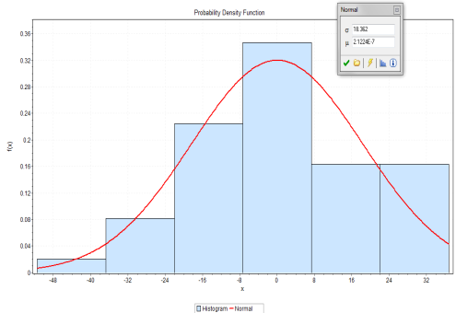 | Source: Author analysis of HTN-2 data.  Bootstrapped residuals from model 3 (see appendix A20)
Dist(2) – Baseline SBP | 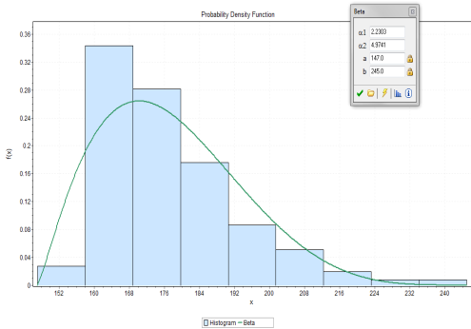 | Source: Author analysis of HTN-2 data.  Data bootstrapped.
Dist(3) – Starting age | 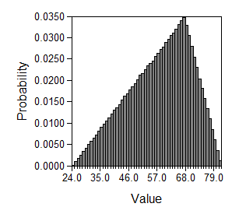 | Source: HTN-2  Triangular, Min = 24·286, Likeliest = 67·733, Max = 81·981; Expected value: 58
Dist(4) – Diabetes mellitus | 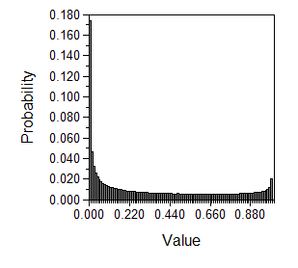 | Source: HTN-2  Beta, Real-numbered parameters, alpha = ((·3396^2)*(1-·3396)/(.475831^2)), beta = (·3396*(1·3396)/(.475831^2))-((.3396^2)*(1-.3396)/(·475831^2)); Expected value: 0·3396
Dist(5) – Proportion female | 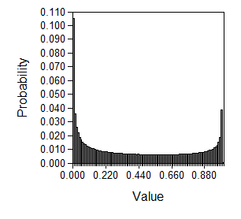 | Source: HTN-2  Beta, Real-numbered parameters, alpha = ((·4245^2)*(1-·4245)/(·49662^2)), beta = (.4245*(1-.4245)/(.49662^2))-((·4245^2)*(1-·4245)/(·49662^2)); Expected value: 0·4245
Dist(6) – Heart rate | 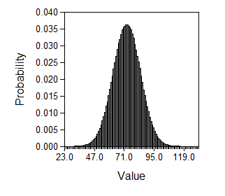 | Source: HTN-2/1  Normal, Mean = 73 (HTN-2), Std Dev = 11 (HTN-1; SD of 15 [HTN-2] would result in a too broad normal distribution); Expected value: 75
Dist(7) – Vital capacity men | 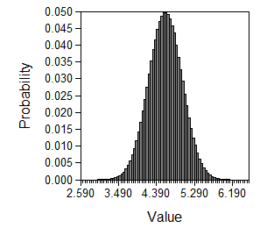 | Normal, Mean = 4·6, Std Dev = 0·4; Expected value: 4·6
Dist(8) – Vital capacity women | 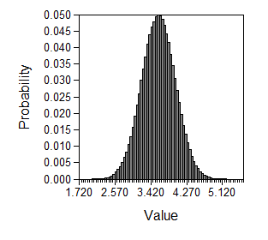 | Normal, Mean = 3·6, Std Dev = 0·4; Expected value: 3·6
Dist(9) – Current smoker | 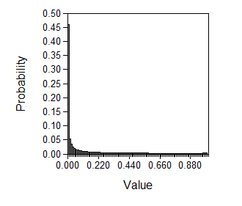 | Source: HTN-2  Beta, Real-numbered parameters, alpha = ((·1604^2)*(1-·1604)/(.3687^2)), beta = (·1604*(1-·1604)/(·3687^2))-((·1604^2)*(1-·1604)/(·3687^2)); Expected value: 0·1604
Dist(10) – GGT in men | 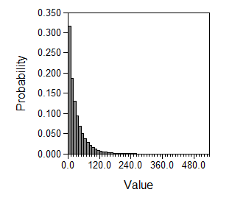 | Gamma, alpha = (31^2)/(34^2), lambda = 31/(34^2); Expected value: 31
Dist(11) – GGT in women | 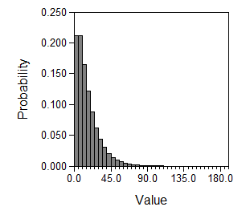 | Gamma, alpha = (16^2)/(14^2), lambda = 16/(14^2); Expected value: 16
Dist(12) – LDL cholesterol | 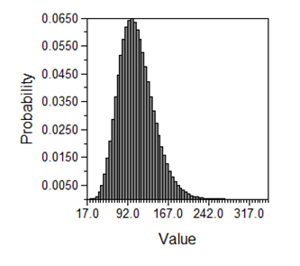 | Source: Egan, 2011  Gamma, alpha = (108^2)/(32^2), lambda = 108/(32^2); Expected value: 108
Dist(13) – HDL cholesterol | 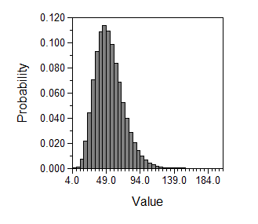 | Source: Egan, 2011  Gamma, alpha = (53^2)/(18.5^2)); lambda = (53)/(18.5^2)); Expected value: 53
Dist(14) – Triglycerides | 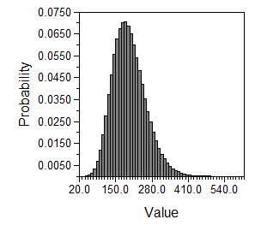 | Source: Egan, 2011  Gamma, alpha = (187·5^2)/(60^2), lambda = 187·5/(60·5^2); Expected value: 187·5
Dist(15) – Alcohol | 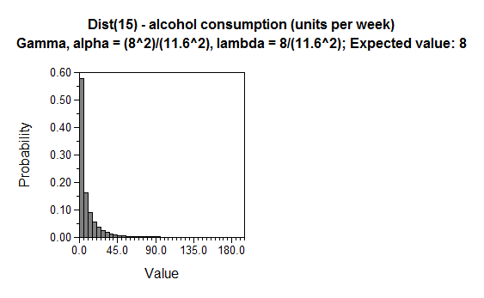 | Source: Dahloef, 2005  Gamma, alpha = (8^2)/(11·6^2), lambda = 8/(11·6^2); Expected value: 8
Dist(16) – Cardiomegaly/LVH | 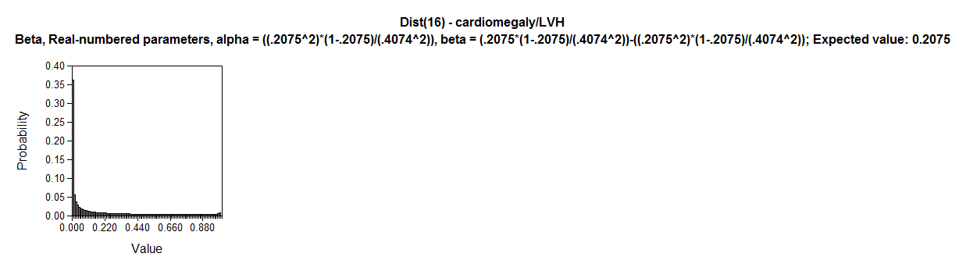 | Beta, Real-numbered parameters, alpha = ((·2075^2)*(1-·2075)/(·4074^2)), beta = (·2075*(1-·2075)/(·4074^2))-((·2075^2)*(1-·2075)/(·4074^2)); Expected value: 0·2075
Dist(17) – Renal Denervation costs incl. procedure | 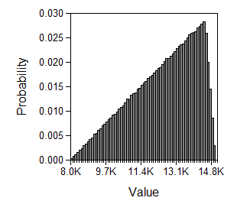 | Source: Medtronic (Symplicity® system)  Triangular, Min = 8000, Likeliest = 14500, Max = 15000; Expected value: 12500
Dist(18) – Costs for stable AP (annually) | 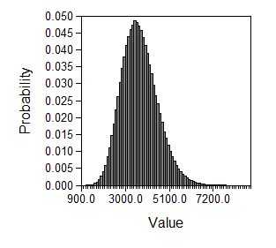 | Source: Reynolds, 2004; Russell, 1998  Gamma, alpha = (3674^2)/(850^2), lambda = 3674/(850^2); Expected value: 3674
Dist(19) – Costs for unstable AP (annually) | 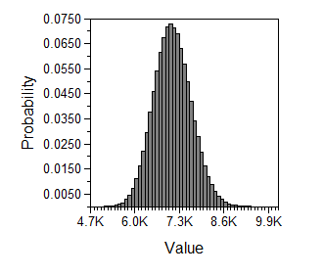 | Source: Weintraub, 2005 (assuming 50% angiographies)  Gamma, alpha = (7104^2)/(550^2), lambda = 7104/(550^2); Expected value: 7104
Dist(20) – Costs for ESRD patients w/o DM | 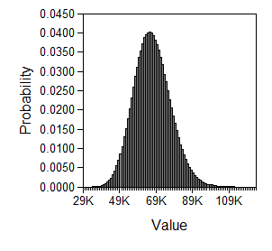 | Source: USRDS 2011 (assuming 75% dialysis patients, 25% transplant patients)  Gamma, alpha = (66844^2)/(10000^2), lambda = 66844/(10000^2); Expected value: 66844
Dist(21) – Costs for ESRD patients w/ DM | 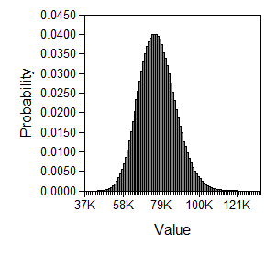 | Source: USRDS 2011 (assuming 75% dialysis patients, 25% transplant patients  Gamma, alpha = (76851^2)/(10000^2), lambda = 76851/(10000^2); Expected value: 76851
Dist(22) – Costs for HF year 1 (annually) | 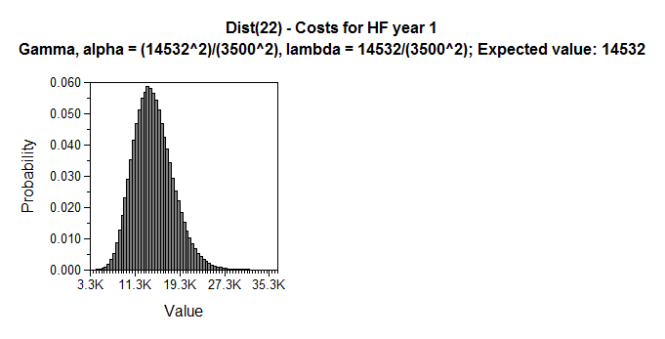 | Source: Feldman, 2005 (based on assumption of 100% OPT, one-yr. average based on 2-yr. cumulative cost).  Gamma, alpha = (14532^2)/(3500^2), lambda = 14532/(3500^2); Expected value: 14532
Dist(23) – Costs for HF years 2 and following (annually) | 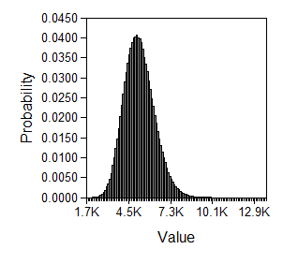 | Source: Feldman, 2005 (based on assumption of 100% OPT, yearly average based on yr.2-7 cost).  Gamma, alpha = (5212^2)/(1000^2), lambda = 5212/(1000^2); Expected value: 5212
Dist(24) – Cost for HTN | 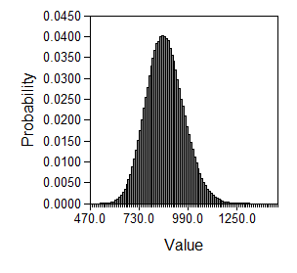 | Source: Medical Expenditure Panel Survey (MEPS), Table 3a  Gamma, alpha = (868^2)/(100^2), lambda = 868/(100^2); Expected value: 868
Dist(25) – Cost for MI (acute, 30 days) | 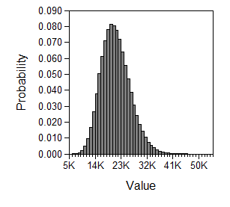 | Source: Schleintz, 2005  Gamma, alpha = (21127^2)/(5000^2), lambda = 21127/(5000^2); Expected value: 21127
Dist(26) – Cost s/p MI (annually) | 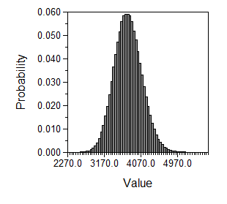 | Source: Ramsey, 2008  Gamma, alpha = (3750^2)/(336.5^2), lambda = 3750/(336.5^2); Expected value: 3750
Dist(28) – Costs for acute stroke (first 30 days) | 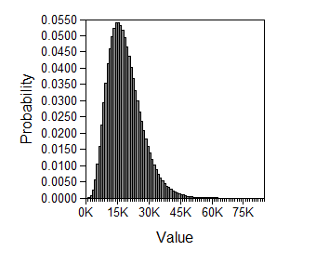 | Source: Luengo-Fernandez, 2009, assumption  Gamma, alpha = (18627^2)/(8000^2), lambda = 18627/(8000^2); Expected value: 18627
Dist(27) – Costs post stroke year 1 (annually) | 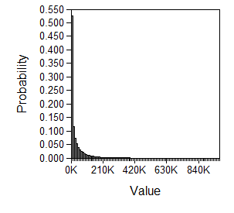 | Source: Luengo-Fernandez, 2009, assumption  Gamma, alpha = (30801^2)/(54052^2), lambda = 30801/(54052^2); Expected value: 30801
Dist(29) – Costs post stroke yrs. 2+ (annually) | 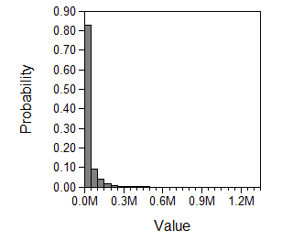 | Source: Engel-Nitz, 2010  Gamma, alpha = (27899^2)/(54052^2), lambda = 27899/(54052^2); Expected value: 27899
Dist(30) – Utility for stable AP | 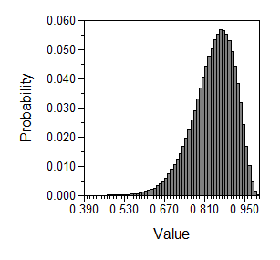 | Source: Sullivan, 2006 and Vella, 2003; assumptions  Beta, Real-numbered parameters, alpha = ((·84^2)*(1-·84)/(·075^2)), beta = (·84*(1-·84)/(·075^2))-((·84^2)*(1-·84)/(·075^2)); Expected value: 0·84
Dist(31) – Utility for unstable AP | 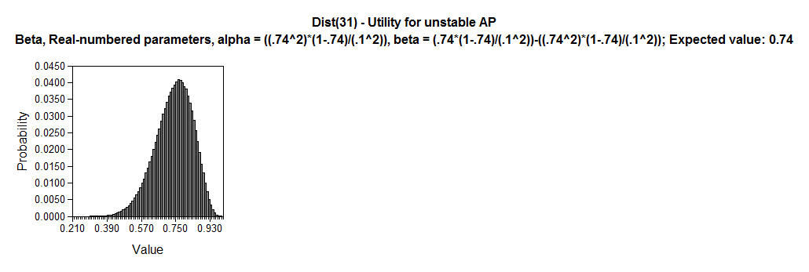 | Source: Assumptions, Glasziou, 2007  Beta, Real-numbered parameters, alpha = ((·74^2)*(1-·74)/(.1^2)), beta = (·74*(1-·74)/(·1^2))-((·74^2)*(1-·74)/(·1^2)); Expected value: 0·74
Dist(32) – Utility for ESRD | 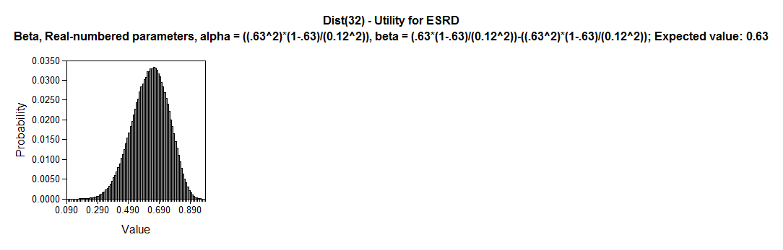 | Source: Lee, 2009  Beta, Real-numbered parameters, alpha = ((·63^2)*(1-·63)/(0·12^2)), beta = (·63*(1-·63)/(0·12^2))-((·63^2)*(1-·63)/(0·12^2)); Expected value: 0·63
Dist(33) – Utility for HF | 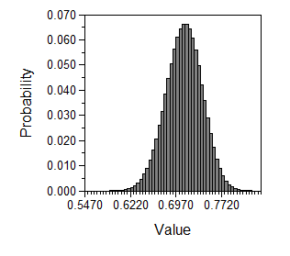 | Source: Chen, 2004  Beta, Real-numbered parameters, alpha = ((·71^2)*(1-·71)/(0·03^2)), beta = (·71*(1-·71)/(0·03^2))-((·71^2)*(1-·71)/(0·03^2)); Expected value: 0·71
Dist(34) – Utility for HTN | 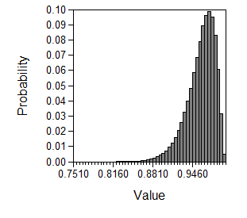 | Source: Sullivan, 2006, assumption  Beta, Real-numbered parameters, alpha = ((·96^2)*(1-·96)/(0·0235^2)), beta = (·96*(1-·96)/(0·0235^2))-((·96^2)*(1-·96)/(0·0235^2)); Expected value: 0·96
Dist(35) – Utility for post-MI (beyond 6 months) | 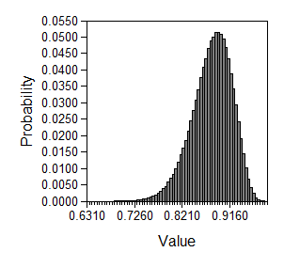 | Source: Grosso 2011 and Pignone 2007  Beta, Real-numbered parameters, alpha = ((·88^2)*(1-·88)/(·04^2)), beta = (·88*(1-·88)/(·04^2))-((·88^2)*(1-·88)/(·04^2)); Expected value: 0·88
Dist(36) – Utility for stroke | 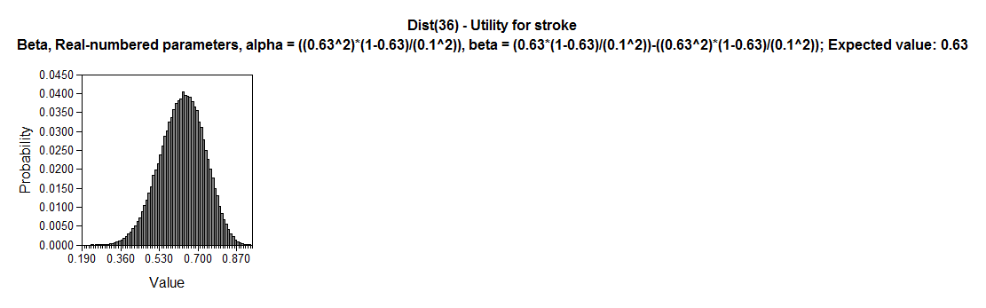 | Source: Grosso 2011 and Darlington 2007  Beta, Real-numbered parameters, alpha = ((0·63^2)*(1-0··63)/(0·1^2)), beta = (0·63*(1-0·63)/(0·1^2))-((0·63^2)*(1-0·63)/(0·1^2)); Expected value: 0·63
Dist(37) – Probability of death in 1st month after stroke | 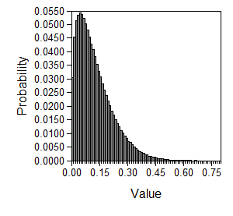 | Beta, Real-numbered parameters, alpha = 1·3999, beta = 9·7616; Expected value: 0·12542221
Dist(38) – Long-term probability of death from stroke | 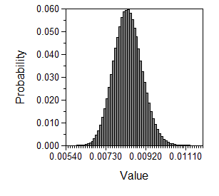 | Beta, Real-numbered parameters, alpha = ((ProbToProb(·395;cl/5)^2)*(1-ProbToProb(·395;cl/5))/(ProbToProb(·0395;cl/5)^2)), beta = (ProbToProb(·395;cl/5)*(1-ProbToProb(·395;cl/5))/(ProbToProb(·0395;cl/5)^2))-((ProbToProb(·395;cl/5)^2)*(1-ProbToProb(·395;cl/5))/(ProbToProb(·0395;cl/5)^2)); Expected value: 0·008340471
Dist(39) – Long-term mortality from MI |  | Beta, Real-numbered parameters, alpha = (((female*ProbToProb(tDieMIf[age]; cl)+(1-female)*ProbToProb(tDieMIm[age]; cl))^2)*(1-(female*ProbToProb(tDieMIf[age]; cl)+(1-female)*ProbToProb(tDieMIm[age]; cl)))/((.1*female*ProbToProb(tDieMIf[age]; cl)+.1*(1-female)*ProbToProb(tDieMIm[age]; cl))^2)), beta = ((female*ProbToProb(tDieMIf[age]; cl)+(1-female)*ProbToProb(tDieMIm[age]; cl))*(1-(female*ProbToProb(tDieMIf[age]; cl)+(1-female)*ProbToProb(tDieMIm[age]; cl)))/((.1*female*ProbToProb(tDieMIf[age]; cl)+.1*(1-female)*ProbToProb(tDieMIm[age]; cl))^2))-(((female*ProbToProb(tDieMIf[age]; cl)+(1-female)*ProbToProb(tDieMIm[age]; cl))^2)*(1-(female*ProbToProb(tDieMIf[age]; cl)+(1-female)*ProbToProb(tDieMIm[age]; cl)))/((.1*female*ProbToProb(tDieMIf[age]; cl)+.1*(1-female)*ProbToProb(tDieMIm[age]; cl))^2)); Expected value: 0·001315601
Dist(40) – Mortality from MI in first month | 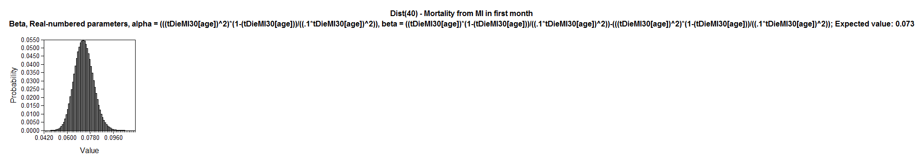 | Beta, Real-numbered parameters, alpha = (((tDieMI30[age])^2)*(1-(tDieMI30[age]))/((·1*tDieMI30[age])^2)), beta = ((tDieMI30[age])*(1-(tDieMI30[age]))/((·1*tDieMI30[age])^2))-(((tDieMI30[age])^2)*(1-(tDieMI30[age]))/((·1*tDieMI30[age])^2)); Expected value: 0·073
Dist(41) – Mortality from AP |  | aBeta, Real-numbered parameters, alpha = (((female*ProbToProb(tDieAPf[age];cl)+(1-female)*ProbToProb(tDieAPm[age];cl))^2)*(1-(female*ProbToProb(tDieAPf[age];cl)+(1-female)*ProbToProb(tDieAPm[age];cl)))/((·1*female*ProbToProb(tDieAPf[age];cl)+·1*(1-female)*ProbToProb(tDieAPm[age];cl))^2)), beta = ((female*ProbToProb(tDieAPf[age];cl)+(1-female)*ProbToProb(tDieAPm[age];cl))*(1-(female*ProbToProb(tDieAPf[age];cl)+(1-female)*ProbToProb(tDieAPm[age];cl)))/((·1*female*ProbToProb(tDieAPf[age];cl)+·1*(1-female)*ProbToProb(tDieAPm[age];cl))^2))-(((female*ProbToProb(tDieAPf[age];cl)+(1-female)*ProbToProb(tDieAPm[age];cl))^2)*(1-(female*ProbToProb(tDieAPf[age];cl)+(1-female)*ProbToProb(tDieAPm[age];cl)))/((·1*female*ProbToProb(tDieAPf[age];cl)+·1*(1-female)*ProbToProb(tDieAPm[age];cl))^2)); Expected value: 0·001315601
Dist(42) – Mortality from ESRD | 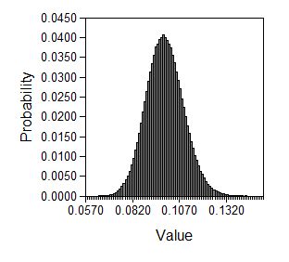 | Beta, Real-numbered parameters, alpha = ((ProbToProb(ptDieESRD;12*cl)^2)*(1-ProbToProb(ptDieESRD;12*cl))/((.1*ProbToProb(ptDieESRD;12*cl))^2)), beta = (ProbToProb(ptDieESRD;12*cl)*(1-ProbToProb(ptDieESRD;12*cl))/((·1*ProbToProb(ptDieESRD;12*cl))^2))-((ProbToProb(ptDieESRD;12*cl)^2)*(1-ProbToProb(ptDieESRD;12*cl))/((·1*ProbToProb(ptDieESRD;12*cl))^2)); Expected value: 0·0993
Dist(43) – Baseline incidence of PAD | 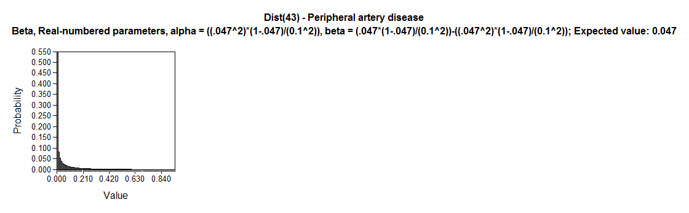 | Beta, Real-numbered parameters, alpha = ((·047^2)*(1-·047)/(0·1^2)), beta = (·047*(1-·047)/(0·1^2))-((·047^2)*(1-·047)/(0·1^2)); Expected value: 0·047
Dist(44) – Baseline incidence of valve disease | 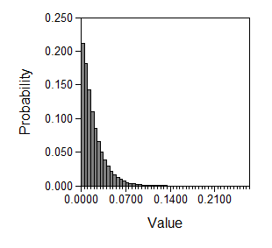 | Beta, Real-numbered parameters, alpha = 1·0919, beta = 56·847; Expected value: 0·018845715
Dist(45) – Probability of HF from AP | 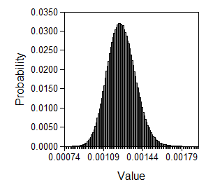 | Beta, Real-numbered parameters, alpha = ((RateToProb(1·5;cl/100)^2)*(1-RateToProb(1·5;cl/100))/((.1*RateToProb(1·5;cl/100))^2)), beta = (RateToProb(1·5;cl/100)*(1-RateToProb(1·5;cl/100))/((.1*RateToProb(1·5;cl/100))^2))-((RateToProb(1·5;cl/100)^2)*(1-RateToProb(1·5;cl/100))/((.1*RateToProb(1·5;cl/100))^2)); Expected value: 0·001249219
Dist(46) – Probability of HF from MI | 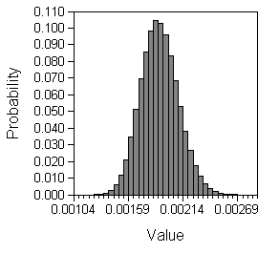 | Beta, Real-numbered parameters, alpha = ((ProbToProb(.108;cl/4.191667)^2)*(1-ProbToProb(.108;cl/4.191667))/((.1*ProbToProb(.108;cl/4.191667))^2)), beta = (ProbToProb(.108;cl/5)*(1-ProbToProb(.108;cl/5))/((.1*ProbToProb(.108;cl/5))^2))-((ProbToProb(.108;cl/5)^2)*(1-ProbToProb(.108;cl/5))/((.1*ProbToProb(.108;cl/5))^2)); Expected value: 0.001902309
Dist(47) – Probability of HF post MI in the first month | 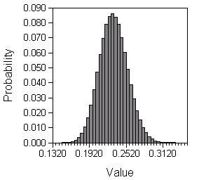 | Beta, Real-numbered parameters, alpha = ((.231^2)*(1-.231)/((.1*.231)^2)), beta = (.231*(1-.231)/((.1*.231)^2))-((.231^2)*(1-.231)/((.1*.231)^2)); Expected value: 0.231
Dist(48) – Probability of MI post AP | 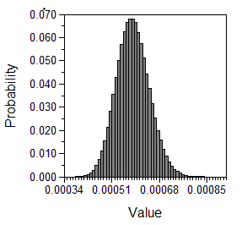 | Beta, Real-numbered parameters, alpha = (((pMI*tMiAP[age])^2)*(1-(pMI*tMiAP[age]))/((.1*pMI*tMiAP[age])^2)), beta = ((pMI*tMiAP[age])*(1-(pMI*tMiAP[age]))/((.1*pMI*tMiAP[age])^2))-(((pMI*tMiAP[age])^2)*(1-(pMI*tMiAP[age]))/((.1*pMI*tMiAP[age])^2)); Expected value: 0.000585242
Dist(49) – Probability of stroke post AP | 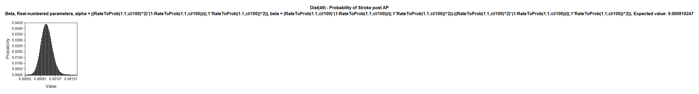 | Beta, Real-numbered parameters, alpha = ((RateToProb(1·1;cl/100)^2)*(1-RateToProb(1·1;cl/100))/((·1*RateToProb(1·1;cl/100))^2)), beta = (RateToProb(1.1;cl/100)*(1-RateToProb(1·1;cl/100))/((·1*RateToProb(1·1;cl/100))^2))-((RateToProb(1·1;cl/100)^2)*(1-RateToProb(1·1;cl/100))/((·1*RateToProb(1·1;cl/100))^2)); Expected value: 0·000916247
Dist(50) – Probability of unstable AP | 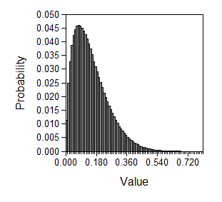 | Beta, Real-numbered parameters, alpha = 1·731, beta = 9·8857; Expected value: 0·149009615
Dist(51) – Family history of MI | 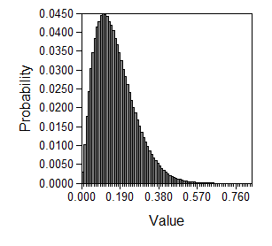 | Beta, Real-numbered parameters, alpha = ((·165^2)*(1-·165)/(0·1^2)), beta = (·165*(1-·165)/(0·1^2))-((·165^2)*(1-·165)/(0·1^2)); Expected value: 0·165
Dist(52) – Utility of MI in the first six months | 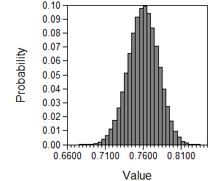 | Source: Aasa, 2010 and Glasziou 2007  Beta, Real-numbered parameters, alpha = ((0·76^2)*(1-0·76)/(0·02^2)), beta = (0·76*(1-0·76)/(0·02^2))-((0·76^2)*(1-0·76)/(0·02^2)); Expected value: 0·76
Dist(55) – RR of death after MI age 60-69 | 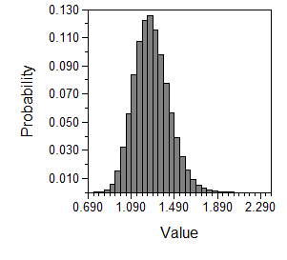 | Log-Normal, u (mean of logs) = ln(1·27), sigma (std dev of logs) = sqrt(ln(1·28/1·27)*2); Expected value: 1·28
Dist(56) – RR of death after MI age >70 | 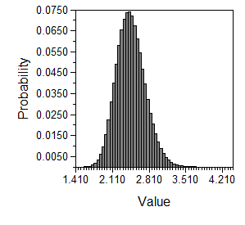 | Log-Normal, u (mean of logs) = ln(2·445), sigma (std dev of logs) = sqrt(ln(2·46/2·445)*2); Expected value: 2·46

A21: Analysis of Clinical Trial Data
Dataset: SYMPLICITY HTN-2 (47), n=106
Subpopulation: denervated patients, n=52
Independent variable: SBP reduction at month 6
Explanatory (dependent) variables analyzed:
- randomization (Symplicity® or control)
- baseline SBP
- number of years on hypertensive medication
- weight (kg)
- smoking status
- history of diabetes mellitus
- medication: on insulin
- medication: on oral diabetes medications
- obesity
- history of hypercholesterinemia
- medication: on Rx for hypercholesterinemia
- history of renal disease (eGFR<60)
- history of renal disease (hemodialysis)
- history of stroke
- history of TIA
- history of carotid artery disease
- no history of cardiac disease
- history of angina pectoris
- history of myocardial infarction
- history of cardiomyopathy
- history of left ventricular hypertrophy
- history of heart failure (yes/no)
- history of heart failure (NYHA class)
- history of valve disease
- history of arrhythmia
- history of other cardiac disease
- family history of PAD/CAD

Methods: Statistical Analysis
We described all variables at baseline, except for SBP reduction by Symplicity® which was analyzed at month 6 by baseline quintiles. We give mean values and standard error (SE) or 95% confidence intervals (CI), or proportions. To test the effect of covariates, we tested the dependent variable first in bivariate linear regression models in the treatment group only. All explanatory variables with a p<0.20 were selected for a multivariate model. We did not further backward-eliminated variables since it was not our goal to identify significant predictors but rather to construct the model with the best overall fit. We also tested for clinically feasible interaction terms.

Results: Descriptive Analysis
Table A.21.1: Baseline Characteristics (all patients)
Variable |  | Mean or % | (95% CI)
baseline SBP (mmHg) |  | 178 | (175-182)
number of years on hypertensive medication | 0-1 years | 2.83%
 | 1-5 years | 22.64%
 | >10 years | 46.23%
 | >5-10 years | 28.30%
weight (kg) |  | 91.6 | (88.1-95.1)
smoking status | current smoker | 16.0%
 | never smoker | 34.9%
 | no | 17.0%
 | prior smoker | 32.1%
history of diabetes mellitus |  | 34.0%
medication: on insulin |  | 6.6%
medication: on oral diabetes medications |  | 24.5%
obesity |  | 44.4%
history of hypercholesterinemia |  | 51.9%
medication: on Rx for hypercholesterinemia |  | 36.8%
history of renal disease (eGFR<60) |  | 9.4%
history of renal disease (hemodialysis) |  | 0%
history of stroke |  | 15.1%
history of TIA |  | 2.8%
history of carotid artery disease |  | 13.2%
no history of cardiac disease |  | 50%
history of angina pectoris |  | 15.1%
history of myocardial infarction |  | 8.5%
history of cardiomyopathy |  | 1.9%
history of left ventricular hypertrophy |  | 20.8%
history of heart failure (yes/no) |  | 8.5%
history of heart failure (NYHA class) | I | 11.1%
 | II | 77.8%
 | III | 11.1%
 | IV | 0%
history of valve disease |  | 1.9%
history of arrhythmia |  | 3.8%
history of other cardiac disease |  | 4.7%
family history of PAD/CAD |  | 22.6%
We described SBP reduction by Symplicity® at month 6 by baseline quintiles:
Table A.21.2: Baseline Reduction in Symplicity(R) Group at Month 6 (by Baseline SBP ranges/intervals)
Baseline SBP | Res. Avg. SBP (95% CI) | Reduction (SE)
150-163 | 135.4 (125.1-145.7) | 23.1 (12.5-33.7)
164-172 | 149.4 (139.8-159.0) | 18.7 (9.0-28.3)
172-179 | 147.4 (140.1-154.7) | 27.4 (20.2-34.5)
180-198 | 141.2 (123.1-159.3) | 45.1 (29.4-60.9)
198-236 | 160.6 (138.7-182.6) | 45.8 (25.8-65.7)
Of note, the resulting overall average SBP at month 6 was 146.7 (95% CI: 140.0-153.4), a -31.6 (25.0-38.3) mmHg reduction compared to baseline

Figure A.21.1: Dot Blot Symplicity®; baseline SBP, months 1, 3, 6
Figure A.21.2: Dot-plot Control; baseline SBP, months 1, 3, 6

Figures A21.3-6: Scatter Plots SBP reduction at month 6 vs. baseline (upper row) and vice versa (lower row)
for Symplicity® group (left) and control group (right)

Results: Bivariate Models
Variable | analyzed as | p-value for treatment group only
randomization | categorical | <0.001
baseline SBP | continuous | 0.007
number of years on hypertensive medication | categorical | n.s. (no type-3 available)
weight (kg) | continuous | 0.829
smoking status | categorical | n.s. (no type-3 available)
history of diabetes mellitus | categorical | 0.325
medication: on insulin | categorical | 0.147
medication: on oral diabetes medications | categorical | 0.071
obesity | categorical | 0.933
history of hypercholesterinemia | categorical | 0.548
medication: on Rx for hypercholesterinemia | categorical | 0.468
history of renal disease (eGFR<60) | categorical | 0.114
history of renal disease (hemodialysis) | no observations
history of stroke | categorical | 0.141
history of TIA | categorical | 0.732
history of carotid artery disease | categorical | 0.206
no history of cardiac disease | categorical | 0.806
history of angina pectoris | categorical | 0.317
history of myocardial infarction | categorical | 0.141
history of cardiomyopathy | categorical | 0.820
history of left ventricular hypertrophy | categorical | 0.802
history of heart failure (yes/no) | categorical | 0.124
history of heart failure (NYHA class) | categorical | n.s. (no type-3 available)
history of valve disease | categorical | 0.508
history of arrhythmia | categorical | 0.192
history of other cardiac disease | categorical | 0.728
family history of PAD/CAD | categorical | 0.879

Results: Multivariate Model (‘Model 1’)
. xi: reg dm6 base i.insulin i.oraldmmeds i.rendx i.stroke i.mi i.hf i.arryth i.randomization
i.insulin _Iinsulin_1-2 (_Iinsulin_1 for insulin==NO omitted)
i.oraldmmeds _Ioraldmmed_1-2 (_Ioraldmmed_1 for oraldmm~s==NO omitted)
i.rendx _Irendx_1-2 (_Irendx_1 for rendx==NO omitted)
i.stroke _Istroke_1-2 (_Istroke_1 for stroke==NO omitted)
i.mi _Imi_1-2 (_Imi_1 for mi==NO omitted)
i.hf _Ihf_1-2 (_Ihf_1 for hf==NO omitted)
i.arryth _Iarryth_1-2 (_Iarryth_1 for arryth==NO omitted)
i.randomization _Irandomiza_1-2 (_Irandomiza_1 for ran~n==CONTROL omitted)

Source | SS df MS Number of obs = 100
-------------+------------------------------ F( 9, 90) = 9.06
Model | 34791.1163 9 3865.67959 Prob > F = 0.0000
Residual | 38396.8301 90 426.631445 R-squared = 0.4754
-------------+------------------------------ Adj R-squared = 0.4229
Total | 73187.9464 99 739.272186 Root MSE = 20.655

------------------------------------------------------------------------------
dm6 | Coef. Std. Err. t P>|t| [95% Conf. Interval]
-------------+----------------------------------------------------------------
base | -.1603011 .1269546 -1.26 0.210 -.4125187 .0919164
_Iinsulin_2 | 3.394146 8.482634 0.40 0.690 -13.45809 20.24638
_Ioraldmme~2 | 7.671074 4.986507 1.54 0.127 -2.235492 17.57764
_Irendx_2 | 6.976079 7.098335 0.98 0.328 -7.126003 21.07816
_Istroke_2 | -12.01654 6.101804 -1.97 0.052 -24.13884 .1057581
_Imi_2 | 11.63091 7.912289 1.47 0.145 -4.088229 27.35006
_Ihf_2 | -7.12671 7.634351 -0.93 0.353 -22.29368 8.040261
_Iarryth_2 | 20.75397 10.85723 1.91 0.059 -.8158271 42.32376
_Irandomiz~2 | -33.79198 4.227596 -7.99 0.000 -42.19083 -25.39312
_cons | 27.69352 22.97859 1.21 0.231 -17.95746 73.34451
------------------------------------------------------------------------------

Model formula
$${∆SBP}_{6months}={Intercept+β_{1}×SBP}_{baseline}+β_{2}×insulin+β_{3}×oral meds+β_{4}×renal Dx+β_{5}×stroke+β_{6}×myocardial infacrtion+β_{7}×heart failure+β_{8}×arrythmia+β_{9}×randomization group$$

Results: Alternative Multivariate Model (‘Model 2’)
. xi: reg dm6 base2 i.randomization
i.randomization _Irandomiza_1-2 (_Irandomiza_1 for ran~n==CONTROL omitted)

Source | SS df MS Number of obs = 100
-------------+------------------------------ F( 2, 97) = 30.66
Model | 28348.1289 2 14174.0645 Prob > F = 0.0000
Residual | 44839.8175 97 462.266159 R-squared = 0.3873
-------------+------------------------------ Adj R-squared = 0.3747
Total | 73187.9464 99 739.272186 Root MSE = 21.5

------------------------------------------------------------------------------
dm6 | Coef. Std. Err. t P>|t| [95% Conf. Interval]
-------------+----------------------------------------------------------------
base2 | -.2541014 .1250019 -2.03 0.045 -.5021956 -.0060072
_Irandomiz~2 | -32.49224 4.300968 -7.55 0.000 -41.02847 -23.95601
_cons | 15.65294 7.874135 1.99 0.050 .0249648 31.28092
------------------------------------------------------------------------------

Model formula
$${∆SBP}_{6months}={Intercept+β_{1}×SBP}_{baseline}+β_{2}×randomization group$$

Results: Multivariate Model in Denervated Subpopulation (‘Model 3’)
. xi: reg dm6 base i.insulin i.oraldmmeds i.rendx i.stroke i.mi i.hf i.arryth if
> randomization=="DENERVATION"
i.insulin _Iinsulin_1-2 (_Iinsulin_1 for insulin==NO omitted)
i.oraldmmeds _Ioraldmmed_1-2 (_Ioraldmmed_1 for oraldmm~s==NO omitted)
i.rendx _Irendx_1-2 (_Irendx_1 for rendx==NO omitted)
i.stroke _Istroke_1-2 (_Istroke_1 for stroke==NO omitted)
i.mi _Imi_1-2 (_Imi_1 for mi==NO omitted)
i.hf _Ihf_1-2 (_Ihf_1 for hf==NO omitted)
i.arryth _Iarryth_1-2 (_Iarryth_1 for arryth==NO omitted)

Source | SS df MS Number of obs = 49
-------------+------------------------------ F( 8, 40) = 2.91
Model | 9406.30446 8 1175.78806 Prob > F = 0.0119
Residual | 16184.4897 40 404.612242 R-squared = 0.3676
-------------+------------------------------ Adj R-squared = 0.2411
Total | 25590.7942 48 533.141545 Root MSE = 20.115

------------------------------------------------------------------------------
dm6 | Coef. Std. Err. t P>|t| [95% Conf. Interval]
-------------+----------------------------------------------------------------
base | -.4265573 .1846608 -2.31 0.026 -.7997708 -.0533439
_Iinsulin_2 | -1.542224 11.6307 -0.13 0.895 -25.04875 21.9643
_Ioraldmme~2 | 7.048957 7.240335 0.97 0.336 -7.584306 21.68222
_Irendx_2 | 16.90983 9.527149 1.77 0.084 -2.345256 36.16492
_Istroke_2 | -8.991983 9.011718 -1.00 0.324 -27.20534 9.221378
_Imi_2 | 21.27753 11.83408 1.80 0.080 -2.640048 45.1951
_Ihf_2 | -11.98241 10.09368 -1.19 0.242 -32.38249 8.417673
_Iarryth_2 | 14.90587 12.59895 1.18 0.244 -10.55755 40.36929
_cons | 40.5835 32.94804 1.23 0.225 -26.00698 107.174
------------------------------------------------------------------------------

Model formula
$${∆SBP}_{6months}={Intercept+β_{1}×SBP}_{baseline}+β_{2}×insulin+β_{3}×oral meds+β_{4}×renal Dx+β_{5}×stroke+β_{6}×myocardial infarction+β_{7}×heart failure +β_{8}×arrhythmia$$

Results: Alternative Bivariate Model in subpopulation (‘Model 4’)
. reg dm6 base2 if randomization=="DENERVATION"

Source | SS df MS Number of obs = 49
-------------+------------------------------ F( 1, 47) = 8.01
Model | 3727.27002 1 3727.27002 Prob > F = 0.0068
Residual | 21863.5241 47 465.181365 R-squared = 0.1456
-------------+------------------------------ Adj R-squared = 0.1275
Total | 25590.7942 48 533.141545 Root MSE = 21.568

------------------------------------------------------------------------------
dm6 | Coef. Std. Err. t P>|t| [95% Conf. Interval]
-------------+----------------------------------------------------------------
base2 | -.4832928 .1707364 -2.83 0.007 -.8267701 -.1398155
_cons | -3.468555 10.42622 -0.33 0.741 -24.44341 17.5063
------------------------------------------------------------------------------

Model formula
$${∆SBP}_{6months}={Intercept+β_{1}×SBP}_{baseline}$$

Examples
A patient with a baseline SBP of 178 mmHg taking no insulin or oral medications for diabetes, with no history of renal disease, stroke myocardial infarction, heart failure, or arrhythmia undergoing RDN with Symplicity® is predicted to have a reduction of 35, 62, 35, and 89 mmHg, respectively, after six months (resulting in an SBP of 143, 115, 142, 88 mmHg). Of note, the observed mean reduction in the trial was 32 mmHg. However, as per the descriptive analysis, there were patients who had positive histories of the aforementioned conditions.
Table A.21.3: Model Predictions (Examples above)
Baseline SBP | Model 1 | Model 2 | Model 3 | Model 4
150 | 119.86 | 95.05 | 126.60 | 74.04
160 | 128.25 | 102.50 | 132.33 | 79.20
170 | 136.65 | 109.96 | 138.07 | 84.37
178 | 143.37 | 115.93 | 142.66 | 88.51
180 | 145.05 | 117.42 | 143.80 | 89.54
r² | 0.48 | 0.39 | 0.37 | 0.15
Table A.21.4: Observed SBP Reductions vs. Model Predictions
Baseline SBP range/mean | SBP observed | Model 1 | Model 2 | Model 3 | Model 4
150-163 / 158.5 | 135.4 | 160.8 | 133.9 | 131.5 | 78.4
164-172 / 168.1 | 149.4 | 168.8 | 141.0 | 137.0 | 83.4
172-179 / 174.8 | 147.4 | 174.4 | 146.0 | 140.8 | 86.8
180-198 / 185.74 | 141.2 | 183.7 | 154.2 | 147.1 | 92.5
198-236 / 206.4 | 160.6 | 201.0 | 169.6 | 159.0 | 103.2

Conclusions
The variance of SBP reduction per standard error or 95% confidence intervals and per visual inspection (scatter plots and dot plots) is substantial; hence predictive modeling for point estimates is difficult. None of the four investigated models offered the clearest advantage over any other or an acceptable r². All models might overestimate the effect. The latter fact, however, might be due to variability (as per figures A19.1 and A19.2). Models 2 and 4 deliver unrealistic results and were therefore eliminated. Despite of the best nominal model fit per r² observed, Model 1 was also eliminated in favor of the ultimately selected Model 3, based on review of the model predictions by a panel of clinical experts.

References
1. D'Agostino RB, Russell MW, Huse DM, Ellison RC, Silbershatz H, Wilson PW, et al. Primary and subsequent coronary risk appraisal: new results from the Framingham study. Am Heart J. 2000;139(2 Pt 1):272-81.
2. Wilson PW, D'Agostino RB, Levy D, Belanger AM, Silbershatz H, Kannel WB. Prediction of coronary heart disease using risk factor categories. Circulation. 1998;97(18):1837-47.
3. Hsu CY, Vittinghoff E, Lin F, Shlipak MG. The incidence of end-stage renal disease is increasing faster than the prevalence of chronic renal insufficiency. Ann Intern Med. 2004;141(2):95-101.
4. Hsu CY, Iribarren C, McCulloch CE, Darbinian J, Go AS. Risk factors for end-stage renal disease: 25-year follow-up. Arch Intern Med. 2009;169(4):342-50.
5. Kannel WB, D'Agostino RB, Silbershatz H, Belanger AJ, Wilson PW, Levy D. Profile for estimating risk of heart failure. Arch Intern Med. 1999;159(11):1197-204.
6. Velagaleti RS, Pencina MJ, Murabito JM, Wang TJ, Parikh NI, D'Agostino RB, et al. Long-term trends in the incidence of heart failure after myocardial infarction. Circulation. 2008;118(20):2057-62.
7. Voss R, Cullen P, Schulte H, Assmann G. Prediction of risk of coronary events in middle-aged men in the Prospective Cardiovascular Munster Study (PROCAM) using neural networks. Int J Epidemiol. 2002;31(6):1253-62; discussion 62-64.
8. Hoerger TJ, Richter A, Bethke AD, Gibbons CB. A Markov Model of Disease Progression and Cost-Effectiveness for Type 2 Diabetes (Technical Report). Annals of Internal Medicine. 2002.
9. D'Agostino RB, Wolf PA, Belanger AJ, Kannel WB. Stroke risk profile: adjustment for antihypertensive medication. The Framingham Study. Stroke. 1994;25(1):40-3.
10. Centers for Disease Control and Prevention. United States Life Tables, 2006. NVSR Volume 58, Number 21 (PHS) 2010-1120. 2010. 2010.
11. United States Renal Data System. Annual Data Report - Volume Three. Reference Tables on End-Stage Renal Disease: Section H - Mortality & causes of death. 2009.
12. Roger VL, Weston SA, Redfield MM, Hellermann-Homan JP, Killian J, Yawn BP, et al. Trends in heart failure incidence and survival in a community-based population. JAMA. 2004;292(3):344-50.
13. Pocock SJ, Wang D, Pfeffer MA, Yusuf S, McMurray JJ, Swedberg KB, et al. Predictors of mortality and morbidity in patients with chronic heart failure. Eur Heart J. 2006;27(1):65-75.
14. Rogers WJ, Frederick PD, Stoehr E, Canto JG, Ornato JP, Gibson CM, et al. Trends in presenting characteristics and hospital mortality among patients with ST elevation and non-ST elevation myocardial infarction in the National Registry of Myocardial Infarction from 1990 to 2006. Am Heart J. 2008;156(6):1026-34.
15. Flack JM, Neaton J, Grimm R, Jr., Shih J, Cutler J, Ensrud K, et al. Blood pressure and mortality among men with prior myocardial infarction. Multiple Risk Factor Intervention Trial Research Group. Circulation. 1995;92(9):2437-45.
16. Barakat K, Wilkinson P, Deaner A, Fluck D, Ranjadayalan K, Timmis A. How should age affect management of acute myocardial infarction? A prospective cohort study. Lancet. 1999;353(9157):955-9.
17. Dennis MS, Burn JP, Sandercock PA, Bamford JM, Wade DT, Warlow CP. Long-term survival after first-ever stroke: the Oxfordshire Community Stroke Project. Stroke. 1993;24(6):796-800.
18. Saposnik G, Hill MD, O'Donnell M, Fang J, Hachinski V, Kapral MK. Variables associated with 7-day, 30-day, and 1-year fatality after ischemic stroke. Stroke. 2008;39(8):2318-24.
19. Haeusler KG, Laufs U, Endres M. Chronic heart failure and ischemic stroke. Stroke. 2011;42(10):2977-82.
20. Divani AA, Vazquez G, Asadollahi M, Qureshi AI, Pullicino P. Nationwide frequency and association of heart failure on stroke outcomes in the United States. J Card Fail. 2009;15(1):11-6.
21. Witt BJ, Brown RD, Jr., Jacobsen SJ, Weston SA, Yawn BP, Roger VL. A community-based study of stroke incidence after myocardial infarction. Ann Intern Med. 2005;143(11):785-92.
22. Seliger SL, Gillen DL, Longstreth WT, Jr., Kestenbaum B, Stehman-Breen CO. Elevated risk of stroke among patients with end-stage renal disease. Kidney Int. 2003;64(2):603-9.
23. Luengo-Fernandez R, Gray AM, Rothwell PM. Costs of stroke using patient-level data: a critical review of the literature. Stroke. 2009;40(2):e18-23.
24. Engel-Nitz NM, Sander SD, Harley C, Rey GG, Shah H. Costs and outcomes of noncardioembolic ischemic stroke in a managed care population. Vasc Health Risk Manag. 2010;6:905-13.
25. Schleinitz MD, Heidenreich PA. A cost-effectiveness analysis of combination antiplatelet therapy for high-risk acute coronary syndromes: clopidogrel plus aspirin versus aspirin alone. Ann Intern Med. 2005;142(4):251-9.
26. Ramsey SD, Clarke LD, Roberts CS, Sullivan SD, Johnson SJ, Liu LZ. An economic evaluation of atorvastatin for primary prevention of cardiovascular events in type 2 diabetes. Pharmacoeconomics. 2008;26(4):329-39.
27. Feldman AM, de Lissovoy G, Bristow MR, Saxon LA, De Marco T, Kass DA, et al. Cost effectiveness of cardiac resynchronization therapy in the Comparison of Medical Therapy, Pacing, and Defibrillation in Heart Failure (COMPANION) trial. J Am Coll Cardiol. 2005;46(12):2311-21.
28. Reynolds MW, Frame D, Scheye R, Rose ME, George S, Watson JB, et al. A systematic review of the economic burden of chronic angina. Am J Manag Care. 2004;10(11 Suppl):S347-57.
29. Russell MW, Huse DM, Drowns S, Hamel EC, Hartz SC. Direct medical costs of coronary artery disease in the United States. Am J Cardiol. 1998;81(9):1110-5.
30. Weintraub WS, Mahoney EM, Lamy A, Culler S, Yuan Y, Caro J, et al. Long-term cost-effectiveness of clopidogrel given for up to one year in patients with acute coronary syndromes without ST-segment elevation. J Am Coll Cardiol. 2005;45(6):838-45.
31. Agency for Healthcare Research and Quality. Medical Expenditure Survey. 2008.
32. Ardian I, a subsidiary of Medtronic, Inc.; 2011.
33. Grosso AM, Bodalia PN, Macallister RJ, Hingorani AD, Moon JC, Scott MA. Comparative clinical- and cost-effectiveness of candesartan and losartan in the management of hypertension and heart failure: a systematic review, meta- and cost-utility analysis. Int J Clin Pract. 2011;65(3):253-63.
34. Darlington AS, Dippel DW, Ribbers GM, van Balen R, Passchier J, Busschbach JJ. Coping strategies as determinants of quality of life in stroke patients: a longitudinal study. Cerebrovasc Dis. 2007;23(5-6):401-7.
35. Aasa M, Henriksson M, Dellborg M, Grip L, Herlitz J, Levin LA, et al. Cost and health outcome of primary percutaneous coronary intervention versus thrombolysis in acute ST-segment elevation myocardial infarction-Results of the Swedish Early Decision reperfusion Study (SWEDES) trial. Am Heart J. 2010;160(2):322-8.
36. Glasziou P, Alexander J, Beller E, Clarke P. Which health-related quality of life score? A comparison of alternative utility measures in patients with Type 2 diabetes in the ADVANCE trial. Health Qual Life Outcomes. 2007;5:21.
37. Pignone M, Earnshaw S, Pletcher MJ, Tice JA. Aspirin for the primary prevention of cardiovascular disease in women: a cost-utility analysis. Arch Intern Med. 2007;167(3):290-5.
38. Chen L, Hay JW. Cost-effectiveness of primary implanted cardioverter defibrillator for sudden death prevention in congestive heart failure. Cardiovasc Drugs Ther. 2004;18(2):161-70.
39. Fryback DG, Dasbach EJ, Klein R, Klein BE, Dorn N, Peterson K, et al. The Beaver Dam Health Outcomes Study: initial catalog of health-state quality factors. Med Decis Making. 1993;13(2):89-102.
40. Sullivan PW, Ghushchyan V. Mapping the EQ-5D index from the SF-12: US general population preferences in a nationally representative sample. Med Decis Making. 2006;26(4):401-9.
41. Vella V. Potential costs and effects of the National Service Framework for Coronary Heart Disease in the UK. Pharmacoeconomics. 2003;21(1):49-60.
42. Lee CP, Chertow GM, Zenios SA. An Empiric Estimate of the Value of Life: Updating the Renal Dialysis Cost-Effectiveness Standard. Value in Health. 2009;12(1):80-7.
43. Sullivan PW, Ghushchyan V. Preference-Based EQ-5D index scores for chronic conditions in the United States. Med Decis Making. 2006;26(4):410-20.
44. Joint National Committee on Prevention Detection Evaluation and Treatment of High Blood Pressure. The seventh report of the Joint National Committee on Prevention, Detection, Evaluation, and Treatment of High Blood Pressure : complete report. Bethesda, MD: The Program; 2004.
45. Anderson KM, Wilson PW, Odell PM, Kannel WB. An updated coronary risk profile. A statement for health professionals. Circulation. 1991;83(1):356-62.
46. Project Management Institute. A guide to the project management body of knowledge (PMBOK guide). 3rd ed. Newtown Square, PA
Evanston, IL: Project Management Institute; EIS Digital Publishing; 2004:1 CD-ROM.
47. Esler MD, Krum H, Sobotka PA, Schlaich MP, Schmieder RE, Bohm M. Renal sympathetic denervation in patients with treatment-resistant hypertension (The Symplicity HTN-2 Trial): a randomised controlled trial. Lancet. 2010;376(9756):1903-9.
48. Segura J, Cerezo C, Garcia-Donaire JA, Schmieder RE, Praga M, de la Sierra A, et al. Validation of a therapeutic scheme for the treatment of resistant hypertension. J Am Soc Hypertens. 2011;5(6):498-504.
49. de la Sierra A, Segura J, Banegas JR, Gorostidi M, de la Cruz JJ, Armario P, et al. Clinical features of 8295 patients with resistant hypertension classified on the basis of ambulatory blood pressure monitoring. Hypertension. 2011;57(5):898-902.
50. Bisognano JD, Bakris G, Nadim MK, Sanchez L, Kroon AA, Schafer J, et al. Baroreflex activation therapy lowers blood pressure in patients with resistant hypertension: results from the double-blind, randomized, placebo-controlled Rheos pivotal trial. J Am Coll Cardiol. 2011;58(7):765-73.
51. Daugherty SL, Powers JD, Magid DJ, Tavel HM, Masoudi FA, Margolis KL, et al. Incidence and prognosis of resistant hypertension in hypertensive patients. Circulation. 2012;125(13):1635-42.

