Online Appendix for the following JACC article
TITLE: A Meta-Analysis Reporting Effects of Angiotensin Converting Enzyme Inhibitors and Angiotensin Receptor Blockers in Patients Without Heart Failure

AUTHORS: Gianluigi Savarese, MD*, Pierluigi Costanzo, MD*, John George Franklin Cleland, MD, Enrico Vassallo, MD, Giuseppe Rosano, MD, PhD, Pasquale Perrone-Filardi, MD, PhD

APPENDIX

Potential effect modifier | Composite Outcome |  |  | MI |  | Cardiovascular Death |  | All Cause Death |  | Stroke |  | Heart Failure new onset |  | Diabetes Mellitus new onset
Potential effect modifier | Change in tau² |  | P | Change in tau² | P | Change in tau² | P | Change in tau² | P | Change in tau² | P | Change in tau² | P | Change in tau² | P
ARBs
Age | -0.59 | 0.572 |  | 1.61 | 0.147 | -0.87 | 0.416 | -0.54 | 0.601 | -1.23 | 0.273 | 2.54 | 0.052 | -0.20 | 0.857
Women | 0.22 | 0.832 |  | 0.38 | 0.711 | 0.74 | 0.487 | -0.62 | 0.546 | -1.94 | 0.110 | 0.12 | 0.911 | -0.53 | 0.650
BMI | 0.80 | 0.445 |  | -0.72 | 0.494 | 1.56 | 0.170 | -0.17 | 0.872 | 0.05 | 0.963 | -0.34 | 0.746 | -0.09 | 0.938
Hypertension | 0.48 | 0.649 |  | -1.67 | 0.140 | 1.05 | 0.340 | 0.45 | 0.664 | 0.97 | 0.385 | -2.31 | 0.069 | 0.48 | 0.678
Diabetes | -0.05 | 0.962 |  | -2.05 | 0.074 | 1.01 | 0.351 | 1.44 | 0.180 | 1.19 | 0.286 | -2.39 | 0.062 | 0.59 | 0.615
Coronary artery disease | -0.07 | 0.943 |  | 1.71 | 0.125 | -0.98 | 0.357 | -1.88 | 0.097 | -0.08 | 0.942 | -0.89 | 0.423 | 1.52 | 0.370
B Blocker | 0.17 | 0.869 |  | -0.33 | 0.755 | 0.91 | 0.413 | 0.20 | 0.849 | -1.08 | 0.360 | 1.08 | 0.329 | 0.78 | 0.579
Aspirin | -0.40 | 0.719 |  | -0.01 | 0.993 | 0.16 | 0.889 | 1.53 | 0.223 | 0.31 | 0.806 | 0.98 | 0.432 | NA | NA
Statin | 0.25 | 0.814 |  | -1.41 | 0.217 | 0.37 | 0.732 | 1.03 | 0.351 | 1.10 | 0.352 | 0.39 | 0.726 | 0.82 | 0.499
Diuretic | -0.84 | 0.446 |  | -1.47 | 0.216 | 1.62 | 0.246 | -0.03 | 0.977 | -1.52 | 0.267 | -2.39 | 0.097 | 0.42 | 0.749
Calcium Channel Blocker | -1.20 | 0.296 |  | -1.69 | 0.166 | 0.76 | 0.502 | 0.20 | 0.853 | -1.44 | 0.247 | -1.37 | 0.241 | 0.77 | 0.581
Systolic Blood Pressure baseline | -0.07 | 0.948 |  | 0.35 | 0.741 | 0.08 | 0.943 | -0.05 | 0.961 | -0.52 | 0.641 | -2.02 | 0.113 | -0.47 | 0.683
Diastolic Blood Pressure baseline | 0.30 | 0.771 |  | 1.08 | 0.323 | 0.08 | 0.939 | -0.17 | 0.872 | -0.44 | 0.690 | 0.06 | 0.954 | -0.63 | 0.594
Delta Systolic Blood Pressure | 0.33 | 0.751 |  | 0.38 | 0.716 | 0.85 | 0.442 | -1.21 | 0.264 | -1.36 | 0.268 | -1.38 | 0.239 | -0.58 | 0.619
Delta Diastolic Blood Pressure | 0.34 | 0.742 |  | 0.66 | 0.534 | 0.72 | 0.509 | -1.29 | 0.238 | -1.42 | 0.251 | -0.99 | 0.380 | -0.59 | 0.613
Quality of trial | 0.90 | 0.393 |  | 0.18 | 0.864 | 0.34 | 0.748 | 0.09 | 0.932 | 0.74 | 0.492 | 1.82 | 0.129 | 0.13 | 0.912
Event rate placebo | -0.47 | 0.651 |  | 0.18 | 0.859 | -0.62 | 0.557 | -0.10 | 0.921 | 0.32 | 0.765 | -1.94 | 0.110 | 0.80 | 0.505
ACE-Is
Age | -0.87 | 0.402 |  | -0.09 | 0.929 | -0.95 | 0.362 | 0.41 | 0.690 | -0.25 | 0.811 | 0.33 | 0.748 | -1.50 | 0.231
Women | 0.49 | 0.637 |  | 0.05 | 0.964 | 0.71 | 0.497 | 0.69 | 0.506 | -0.91 | 0.384 | 2.05 | 0.080 | 0.22 | 0.843
BMI | 2.25 | 0.266 |  | 0.18 | 0.886 | 1.04 | 0.487 | 2.23 | 0.269 | 2.32 | 0.259 | -0.25 | 0.843 | NA | NA
Hypertension | 1.16 | 0.277 |  | 0.22 | 0.833 | 1.32 | 0.220 | 0.97 | 0.357 | -0.22 | 0.834 | 1.33 | 0.233 | -1.68 | 0.192
Diabetes | 1.23 | 0.249 |  | 0.29 | 0.776 | 0.76 | 0.465 | 1.13 | 0.286 | 1.20 | 0.264 | 0.64 | 0.544 | -1.96 | 0.145
Coronary artery disease | -1.27 | 0.259 |  | -0.80 | 0.452 | 0.44 | 0.668 | -0.34 | 0.745 | 0.01 | 0.991 | 1.01 | 0.388 | 0.92 | 0.526
B Blocker | 0.09 | 0.927 |  | -0.51 | 0.622 | 1.27 | 0.241 | 0.43 | 0.681 | 1.63 | 0.147 | -2.12 | 0.088 | 0.08 | 0.944
Aspirin | -1.45 | 0.185 |  | -0.64 | 0.541 | -1.11 | 0.298 | -1.83 | 0.105 | -0.66 | 0.531 | -1.19 | 0.278 | -0.30 | 0.782
Statin | 0.06 | 0.952 |  | -0.07 | 0.948 | 0.74 | 0.481 | -0.18 | 0.859 | 0.09 | 0.933 | -1.26 | 0.254 | 0.09 | 0.931
Diuretic | -0.22 | 0.839 |  | -0.58 | 0.594 | 1.32 | 0.257 | 0.12 | 0.911 | -0.06 | 0.952 | 1.15 | 0.333 | -0.99 | 0.428
Calcium Channel Blocker | -0.12 | 0.908 |  | -0.10 | 0.924 | -1.13 | 0.291 | -0.79 | 0.453 | -0.42 | 0.716 | -0.56 | 0.600 | -1.40 | 0.257
Systolic Blood Pressure baseline | -0.14 | 0.890 |  | -1.12 | 0.287 | 0.17 | 0.867 | 1.19 | 0.258 | -0.12 | 0.906 | -0.24 | 0.818 | 0.01 | 0.994
Diastolic Blood Pressure baseline | -0.22 | 0.828 |  | -1.23 | 0.245 | 0.29 | 0.778 | 0.91 | 0.381 | -0.36 | 0.731 | -0.70 | 0.504 | 1.20 | 0.317
Delta Systolic Blood Pressure | -0.31 | 0.761 |  | -0.54 | 0.604 | -0.64 | 0.540 | -0.99 | 0.350 | 0.56 | 0.591 | -1.15 | 0.294 | 1.47 | 0.280
Delta Diastolic Blood Pressure | -0.54 | 0.607 |  | -0.50 | 0.629 | -0.86 | 0.417 | -1.03 | 0.333 | 0.56 | 0.591 | -1.04 | 0.338 | 2.24 | 0.154
Quality of trial | 2.14 | 0.122 |  | 2.71 | 0.073 | 0.42 | 0.703 | -0.56 | 0.612 | 0.75 | 0.506 | 0.28 | 0.799 | -0.04 | 0.970
Event rate placebo | -1.32 | 0.216 |  | -0.55 | 0.597 | -1.15 | 0.275 | -0.31 | 0.766 | -1.77 | 0.111 | 0.16 | 0.877 | -1.05 | 0.371

Online Appendix Table 1. Influence analysis of potential effect modifiers on the outcomes. ACE-I: Angiotensin Converting Enzyme Inhibitor; ARB: Angiotensin Receptor Blocker; MI: Myocardial Infarction; NA: Not Available.

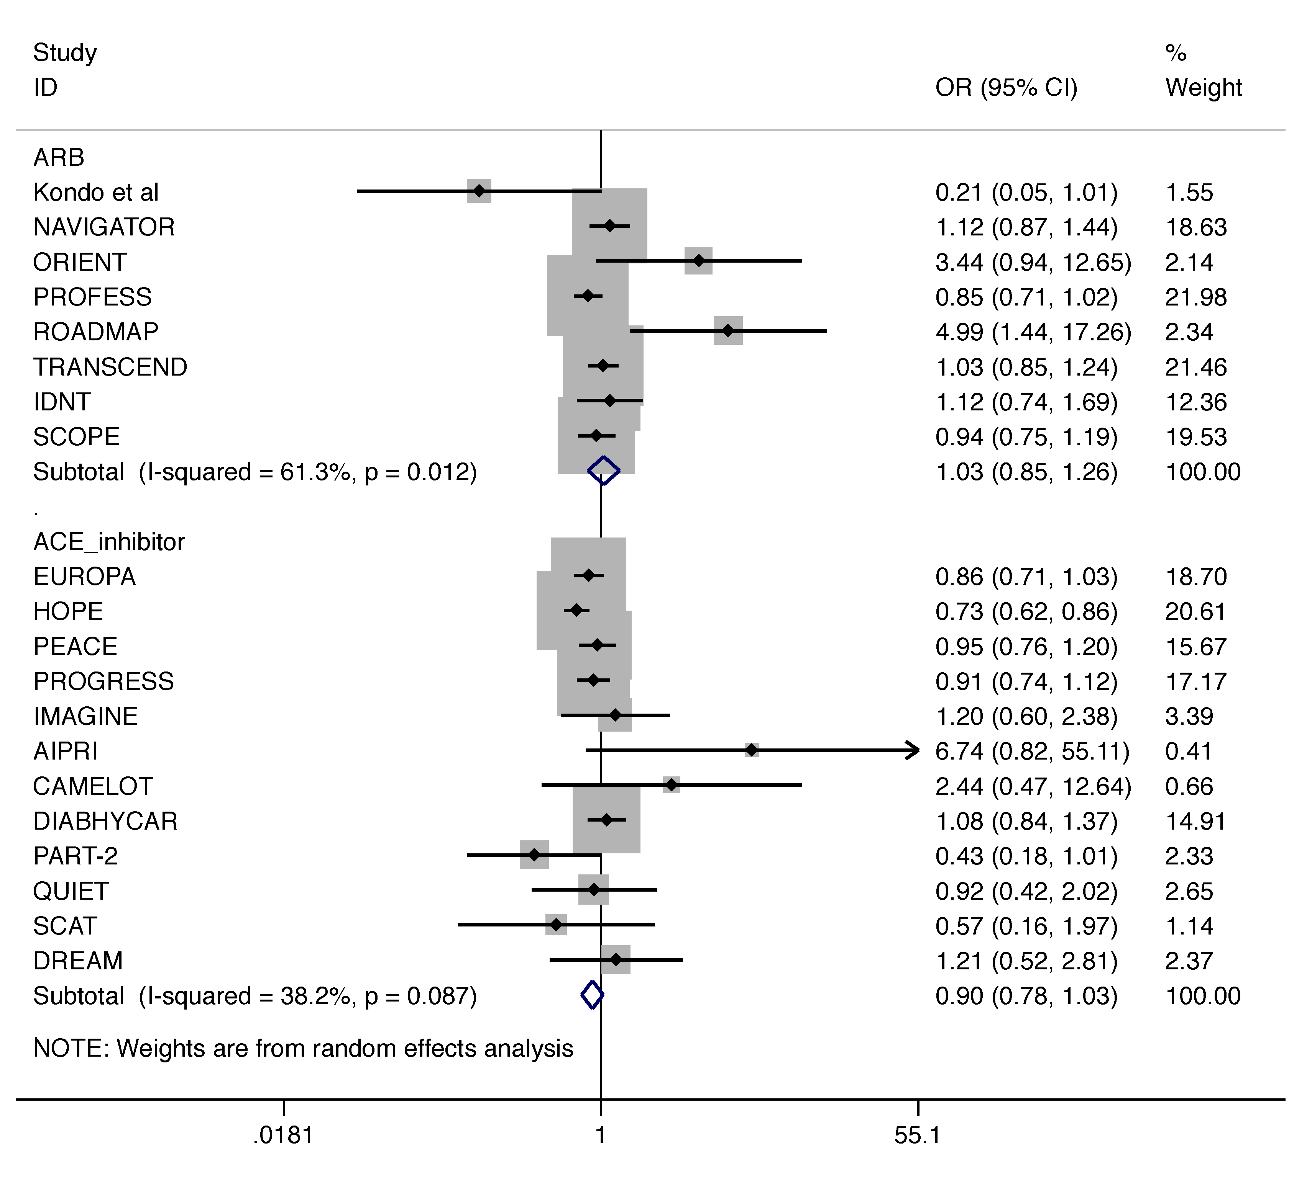
Online Appendix Figure 1. Odds ratios (OR) of cardiovascular death. Solid squares represent ORs in trials and have a size proportional to the number of events. The 95% confidence intervals (CI) for individual trials are denoted by lines and those for the pooled ORs by empty diamonds.

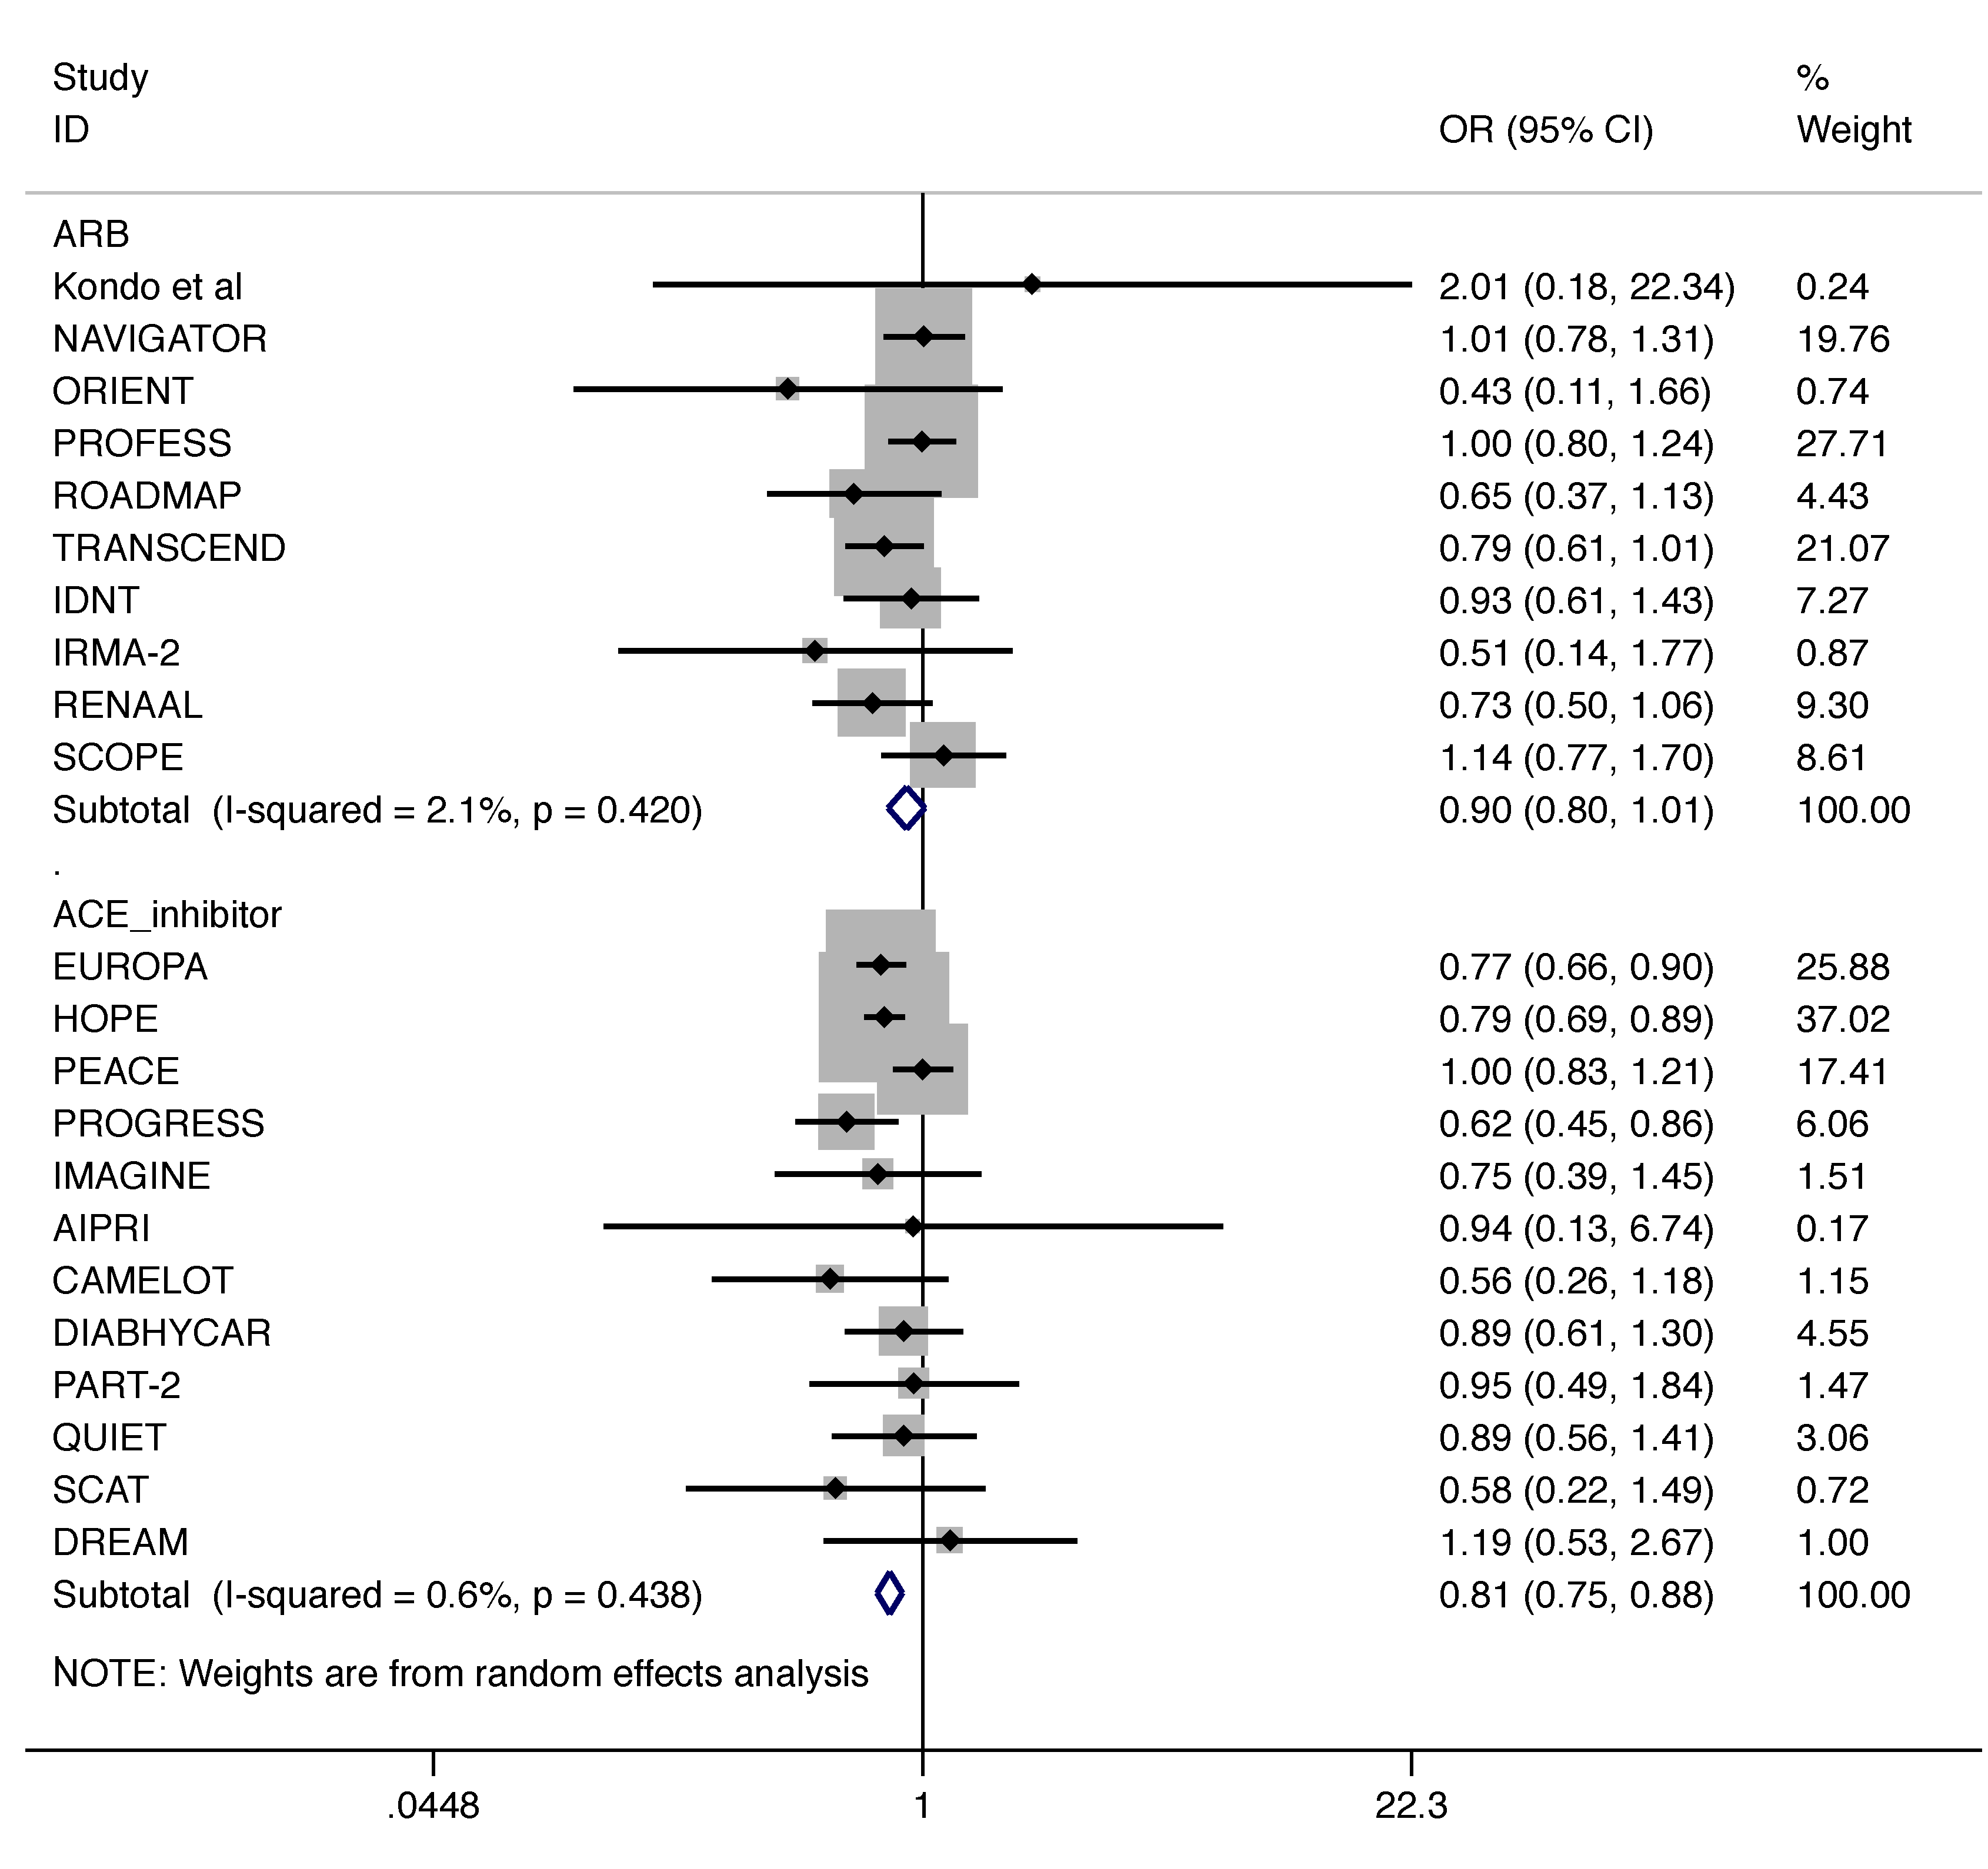
Online Appendix Figure 2. Odds ratios (OR) of myocardial infarction. Solid squares represent ORs in trials and have a size proportional to the number of events. The 95% confidence intervals (CI) for individual trials are denoted by lines and those for the pooled odd ratios by empty diamonds.

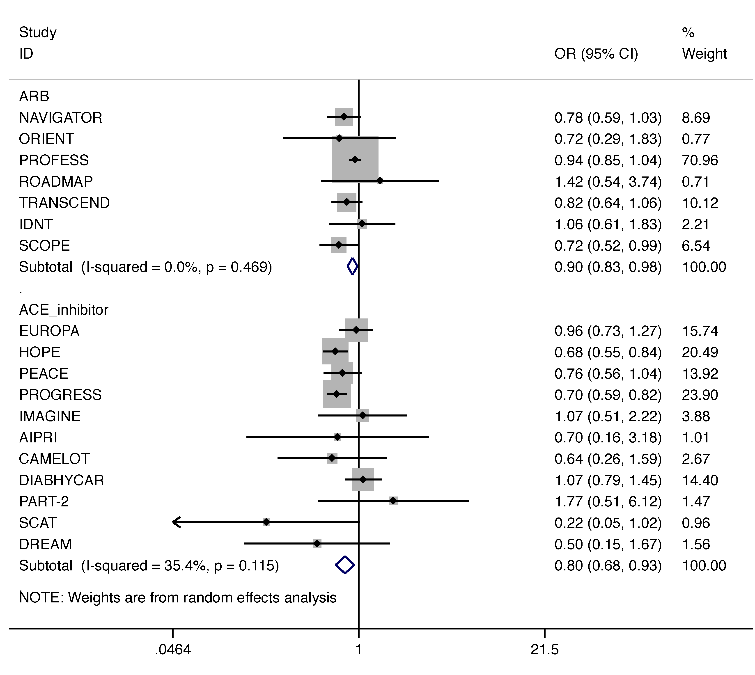
Online Appendix Figure 3. Odds ratios (OR) of stroke or TIA. Solid squares represent ORs in trials and have a size proportional to the number of events. The 95% confidence intervals (CI) for individual trials are denoted by lines and those for the pooled ORs by empty diamonds.

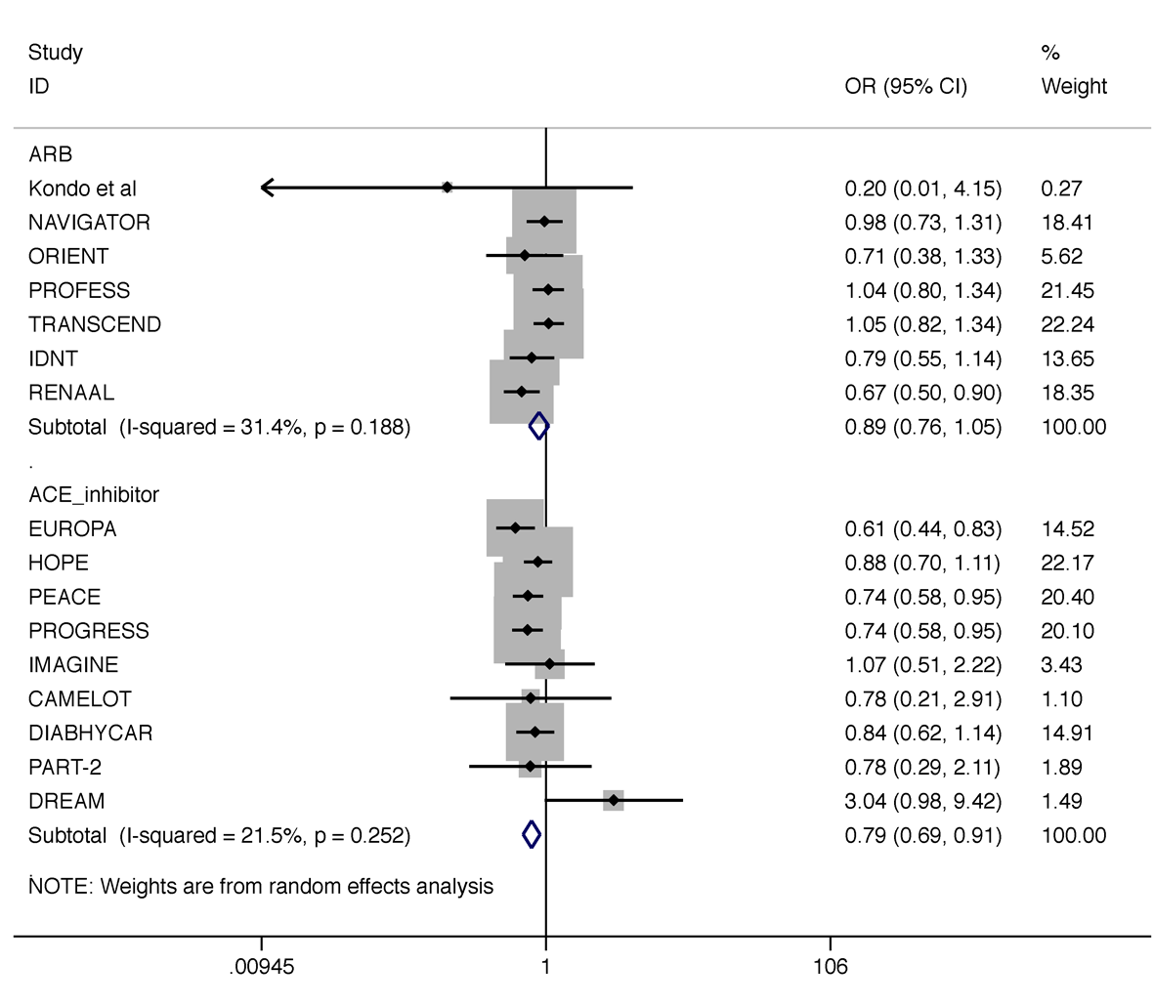
Online Appendix Figure 4. Odds ratios (OR) of new onset heart failure. Solid squares represent ORs in trials and have a size proportional to the number of events. The 95% confidence intervals (CI) for individual trials are denoted by lines and those for the pooled ORs by empty diamonds.

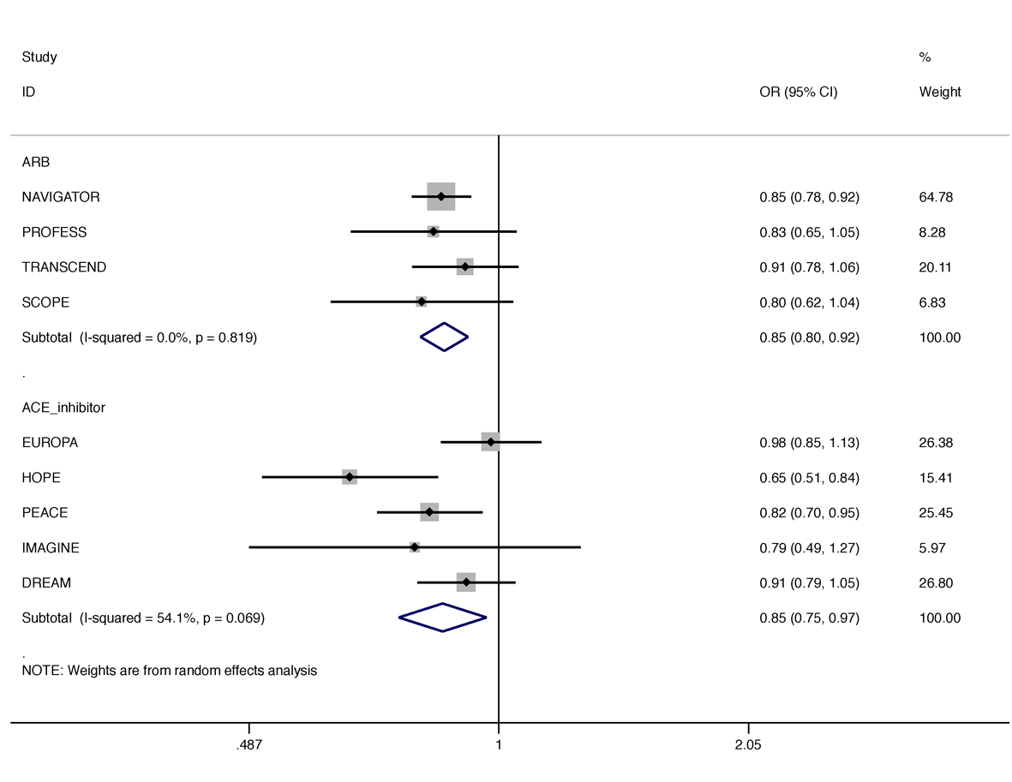
Online Appendix Figure 5. Odds ratios (OR) of new onset diabetes mellitus. Solid squares represent ORs in trials and have a size proportional to the number of events. The 95% confidence intervals (CI) for individual trials are denoted by lines and those for the pooled ORs by empty diamonds.

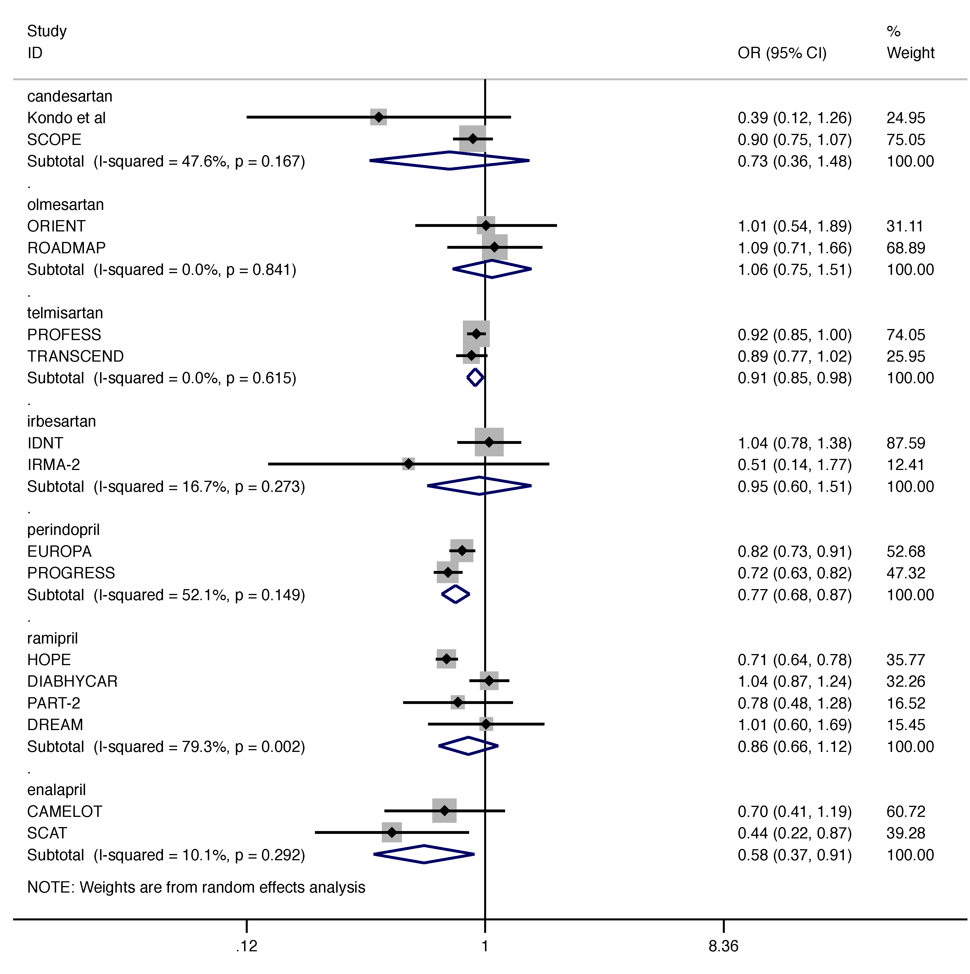
Online Appendix Figure 6. Odds ratios (OR) of composite outcome in each drug category group. Solid squares represent ORs in trials and have a size proportional to the number of events. The 95% confidence intervals (CI) for individual trials are denoted by lines and those for the pooled ORs by empty diamonds.

